N E W R E L E A S E I N F O R M A T I O N
J A N U A R Y − J U N E 2 0 2 0

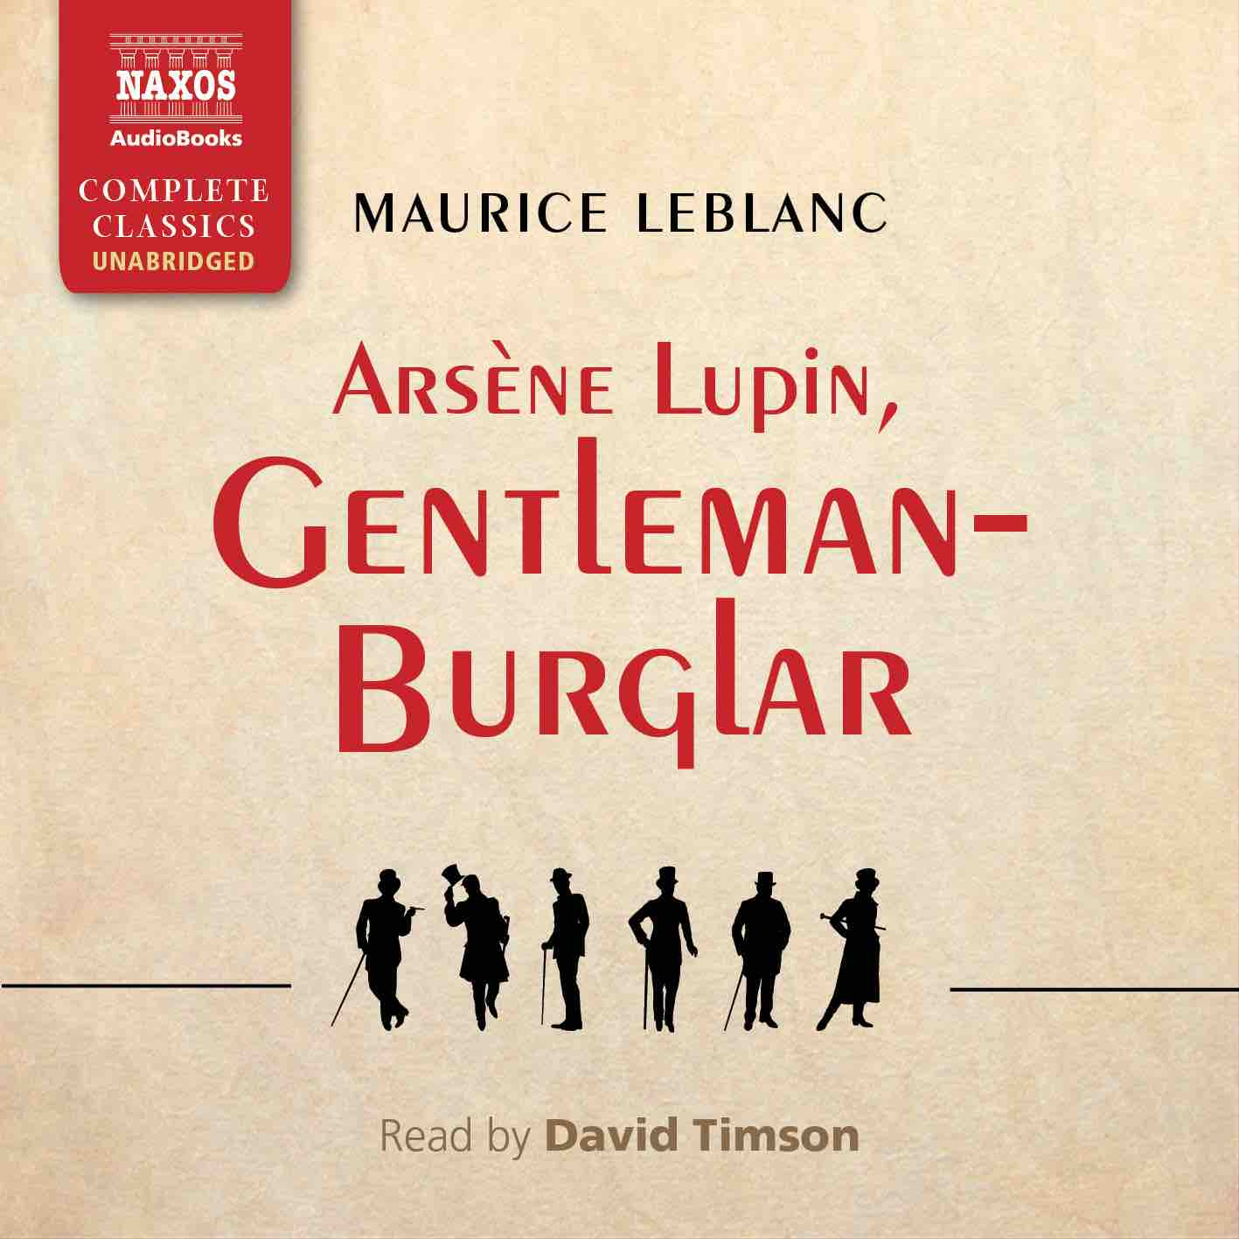
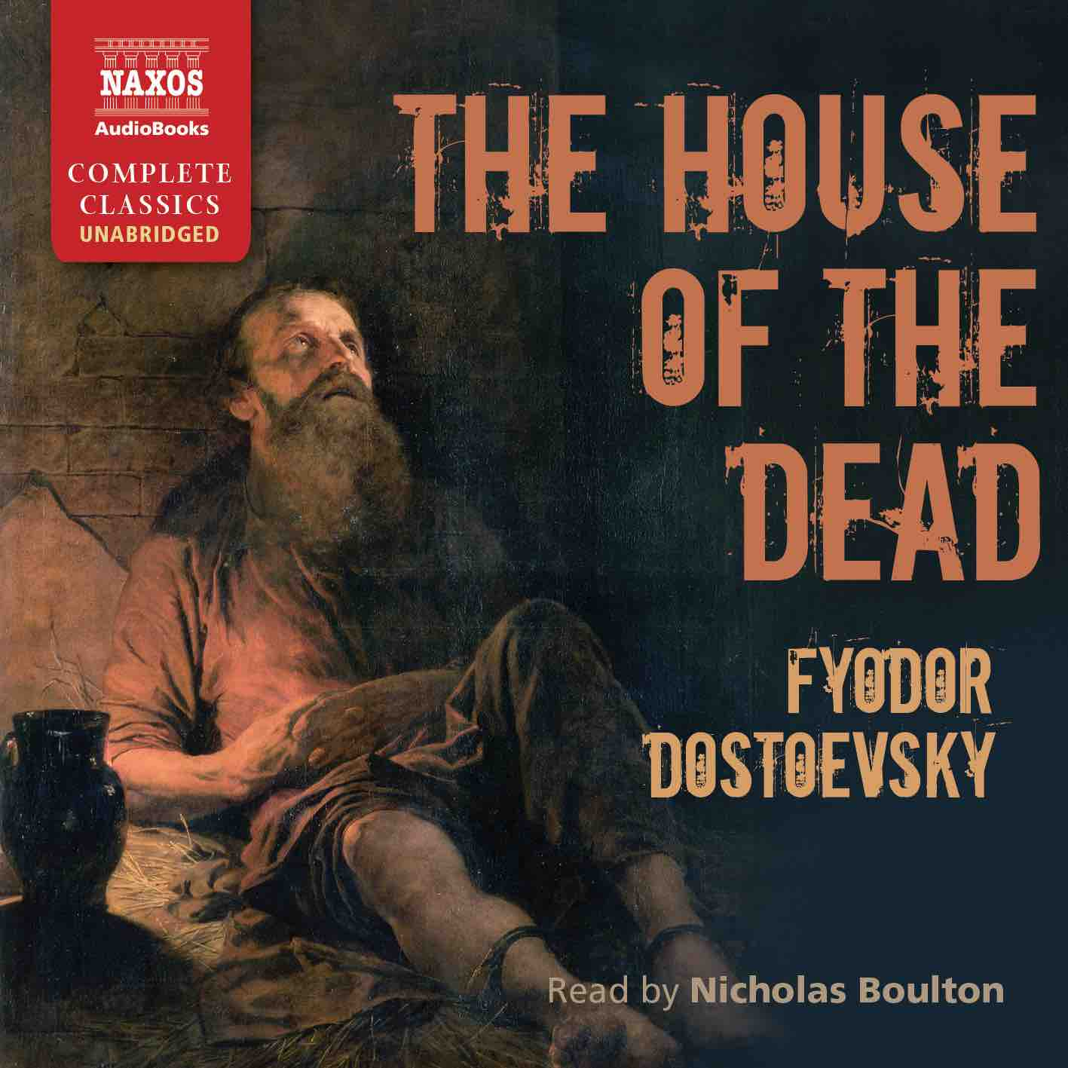
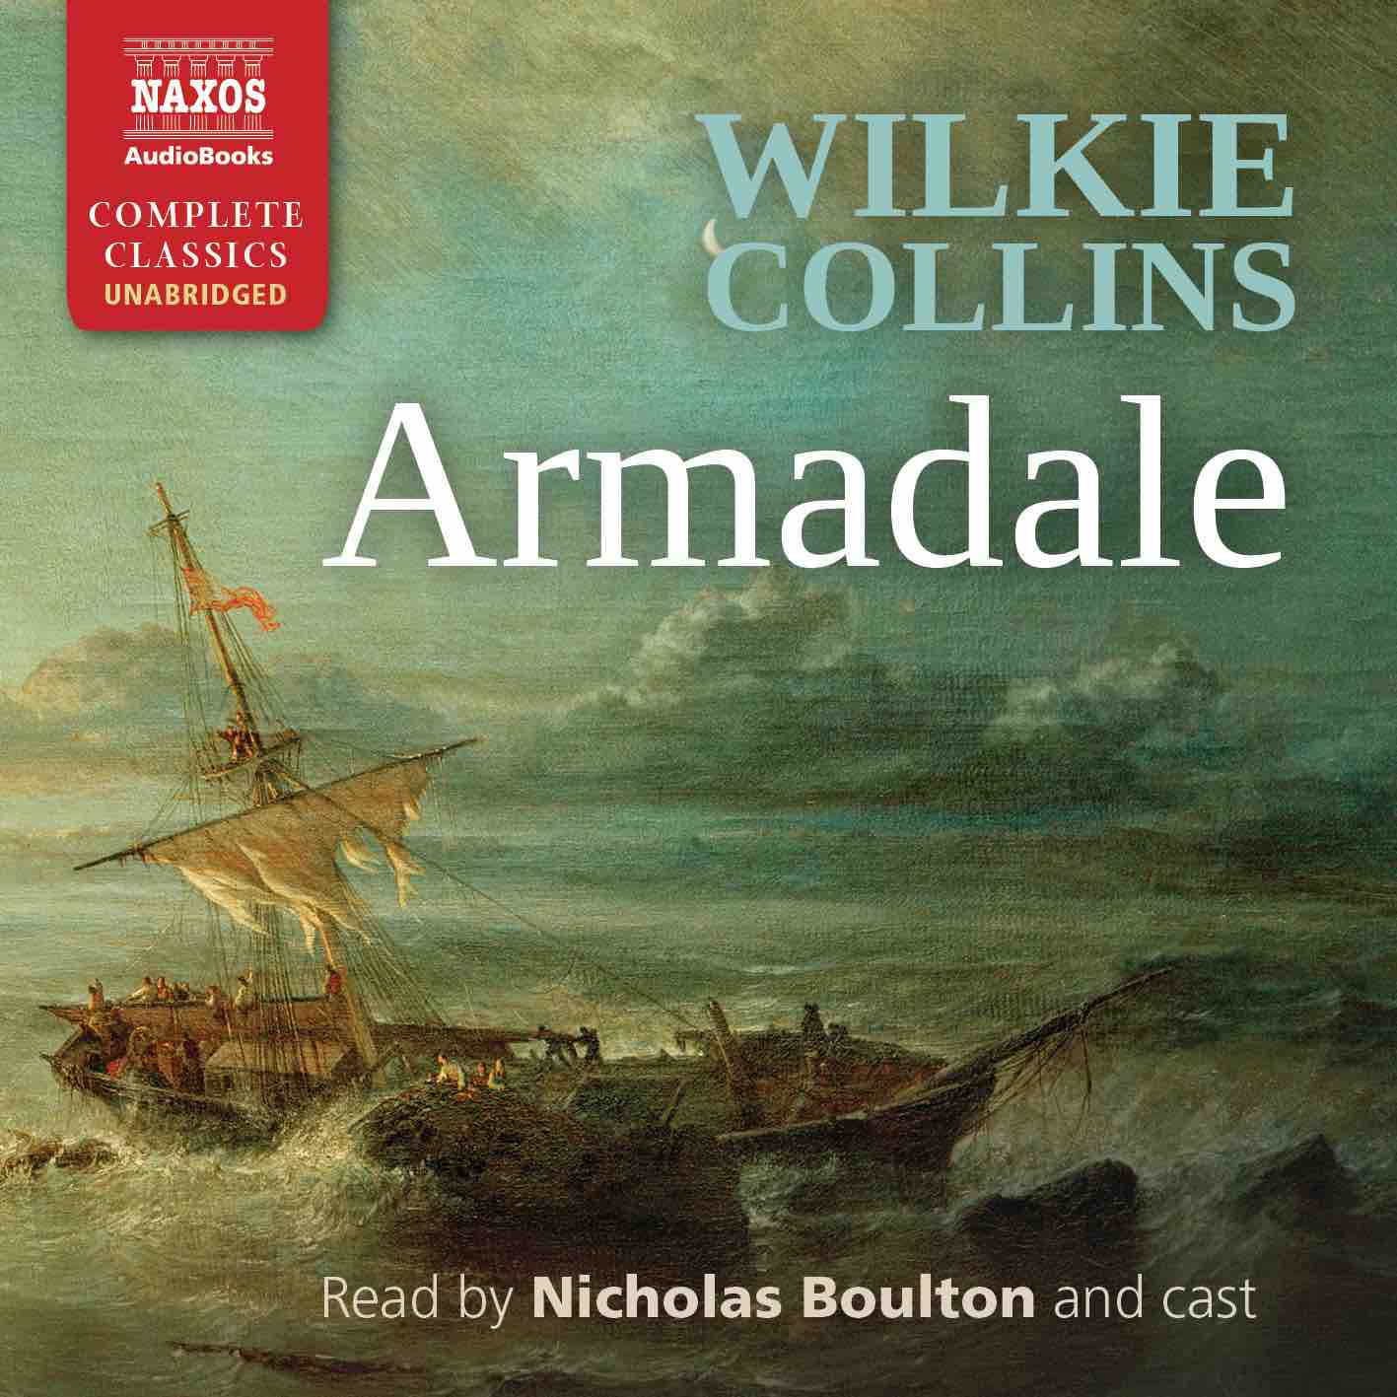
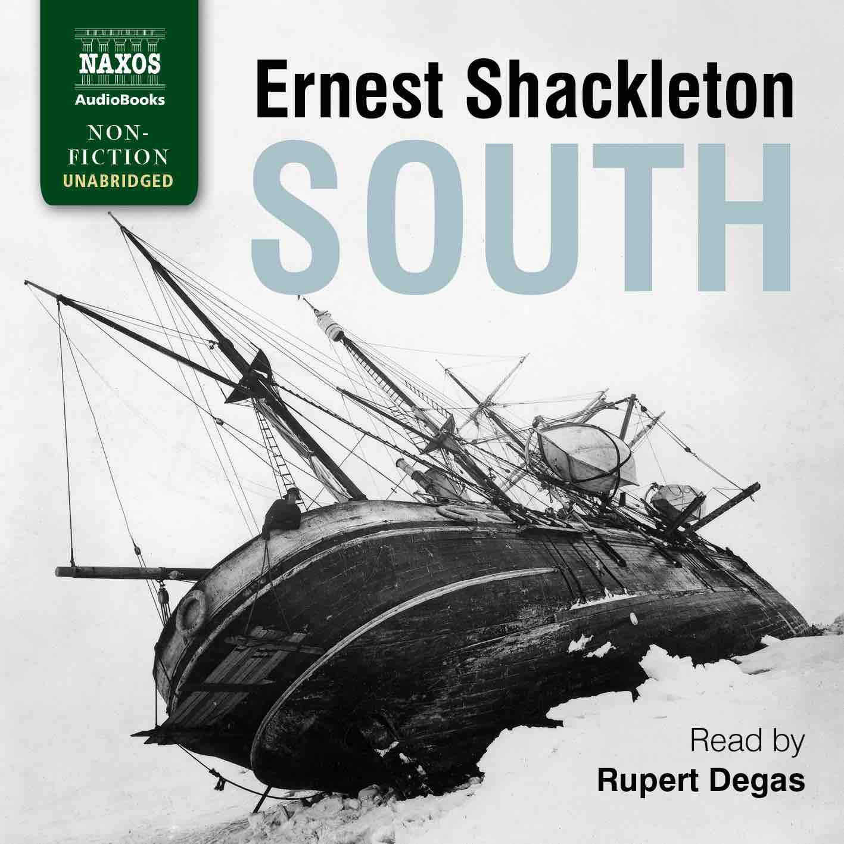

 | Cat No. | ISBN | Title | Hrs | Price | Author | Reader
 | NA0477 | 978-1-78198-338-6 | THE WOMAN WHO SAVED THE CHILDREN | 14 | £27.00 | Clare Mulley | Joely Richardson
Jan | NA0400 | 978-1-78198-244-0 | TWO ON A TOWER | 10 | £21.50 | Thomas Hardy | Leighton Pugh
 | NA0401 | 978-1-78198-246-4 | SOUTH | 16 | £29.00 | Ernest Shackleton | Rupert Degas
 | NA0402 | 978-1-78198-248-8 | THE PROFESSOR | 11.5 | £23.00 | Charlotte Brontë | Roger May
 | NA0403 | 978-1-78198-250-1 | THE HAUNTED HOTEL | 6.75 | £16.00 | Wilkie Collins | Jonathan Keeble
 | NA0476 | 978-1-78198-336-2 | AT SWIM-TWO-BIRDS | 8.25 | £18.00 | Flann O’Brien | Aidan Kelly
Feb | NA0404 | 978-1-78198-252-5 | RODERICK HUDSON | 14 | £27.00 | Henry James | Adam Sims
 | NA0405 | 978-1-78198-254-9 | THE INTERIOR CASTLE | 6.25 | £16.00 | St Teresa of Ávila | Lucy Scott
Mar | NA0406 | 978-1-78198-256-3 | THE FEMALE QUIXOTE | 17.5 | £33.00 | Charlotte Lennox | Juliet Stevenson
 | NA0407 | 978-1-78198-258-7 | THE WEALTH OF NATIONS | 40.5 | £62.00 | Adam Smith | Peter Wickham
 | NA0408 | 978-1-78198-260-0 | THE HOUSE OF THE DEAD | 14 | £27.00 | Fyodor Dostoyevsky | Nicholas Boulton
 | NA0409 | 978-1-78198-262-4 | ARMADALE | 30 | £49.00 | Wilkie Collins | Nicholas Boulton and cast
Apr | NA0410 | 978-1-78198-264-8 | THE YOSEMITE | 7.5 | £18.00 | John Muir | Nick McArdle
 | NA0411 | 978-1-78198-266-2 | ARSÈNE LUPIN, GENTLEMAN-BURGLAR | 6.5 | £16.00 | Maurice Leblanc | David Timson
 | NA0412 | 978-1-78198-268-6 | EFFI BRIEST | 10 | £19.50 | Theodor Fontane | Lucy Scott
May | NA0413 | 978-1-78198-270-9 | A PHILOSOPHICAL ENQUIRY | 6 | £13.00 | Edmund Burke | TBC
 | NA0414 | 978-1-78198-272-3 | THE PERSIAN EXPEDITION | 9.25 | £19.50 | Xenophon | David Timson
 | NA0415 | 978-1-78198-274-7 | NO NAME | 28 | £46.00 | Wilkie Collins | Nicholas Boulton and cast
Jun | NA0416 | 978-1-78198-276-1 | THE BEAST IN THE JUNGLE | 2.25 | £7.00 | Henry James | Kris Dyer
 | NA0417 | 978-1-78198-278-5 | THE MASTERPIECE | 15.5 | £29.00 | Émile Zola | Leighton Pugh

