N E W R E L E A S E I N F O R M A T I O N
J A N U A R Y − J U N E 2 0 2 0

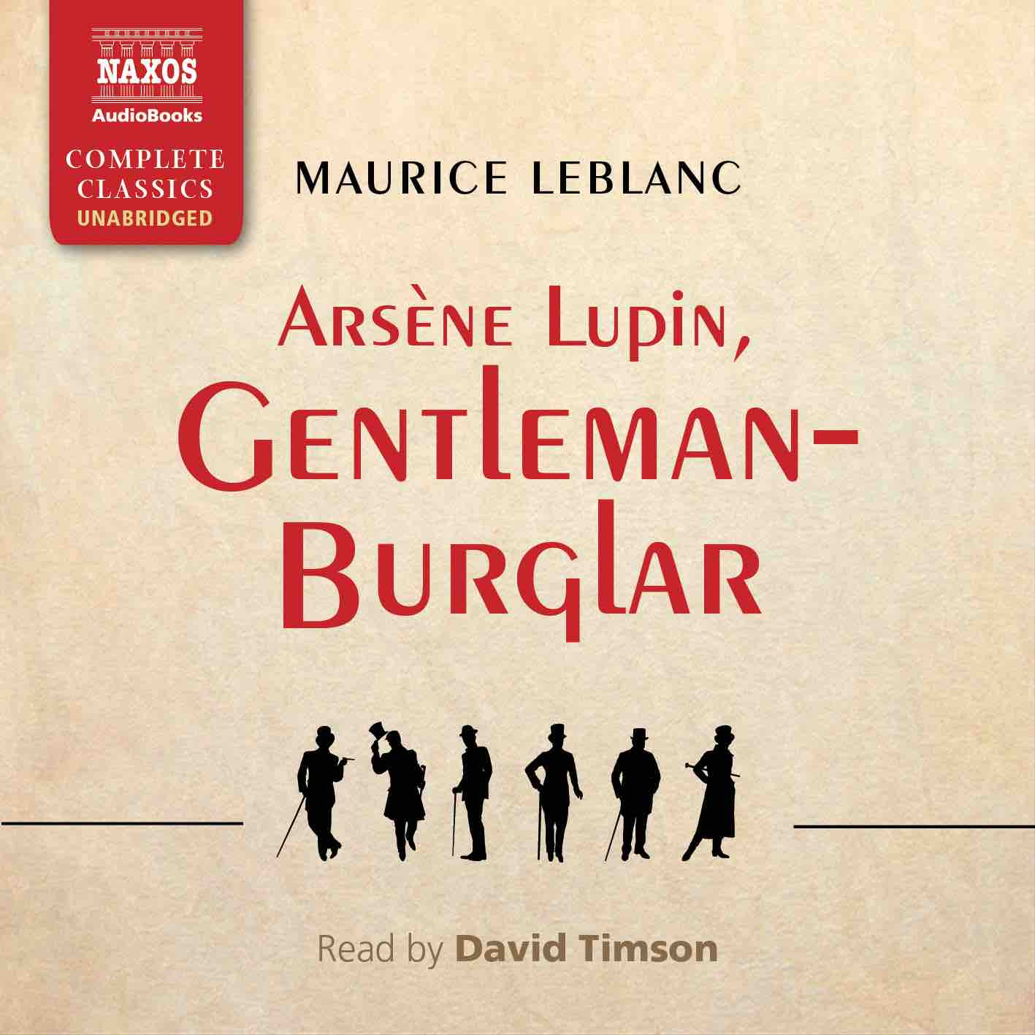
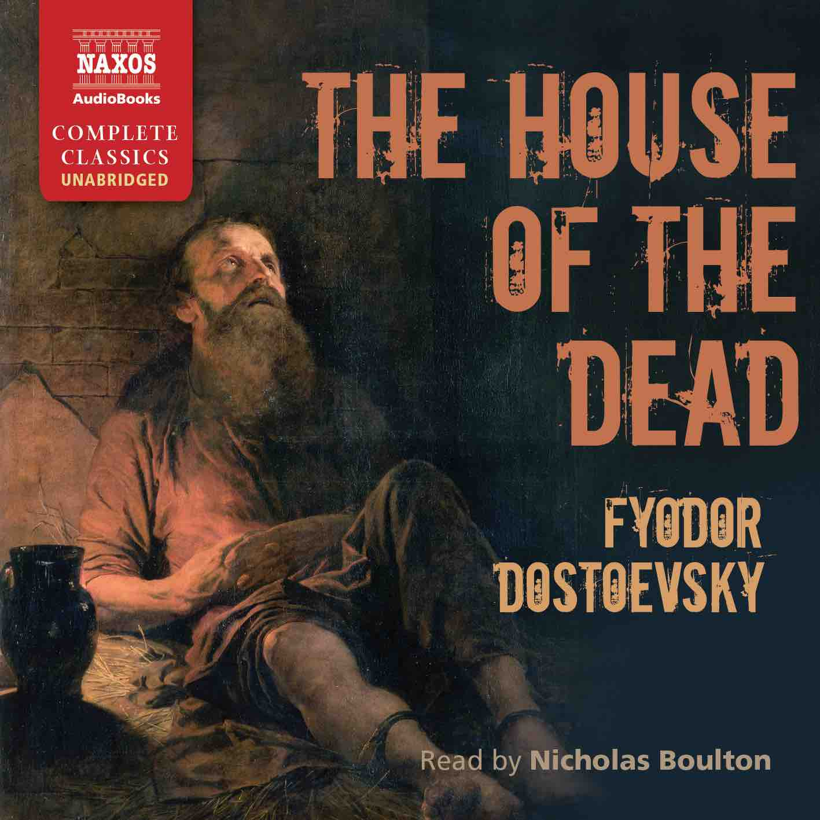
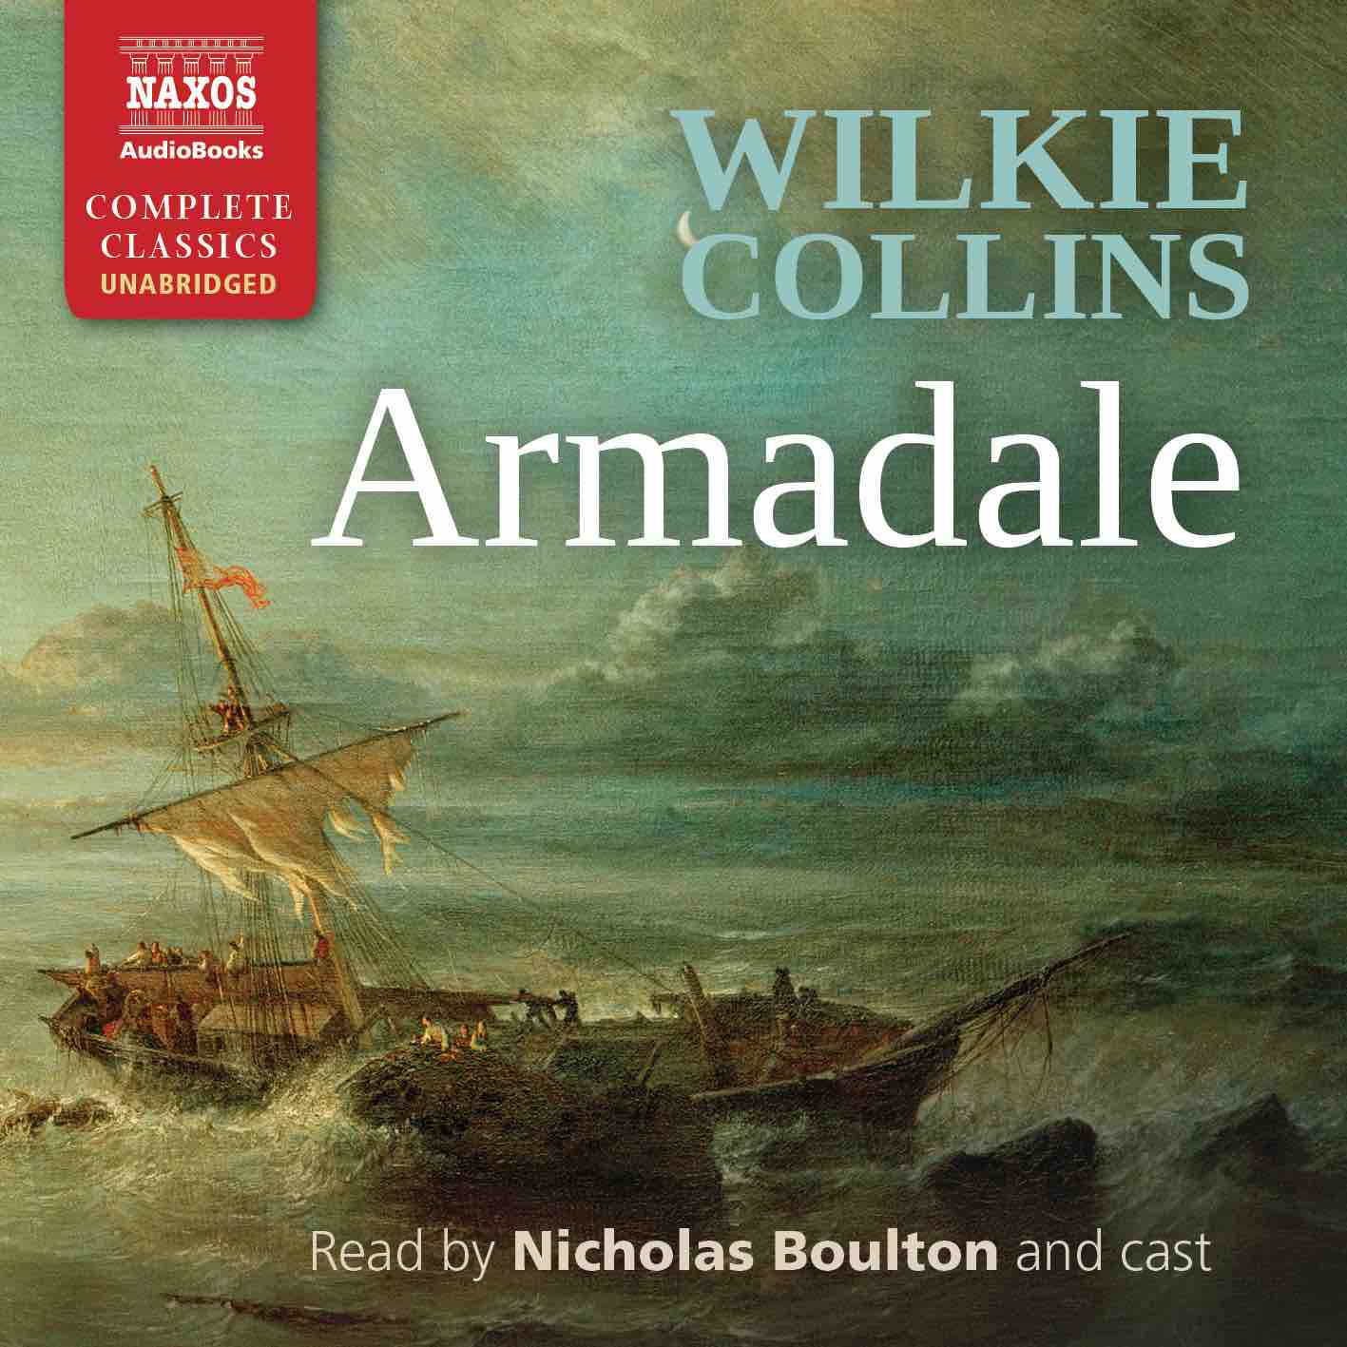
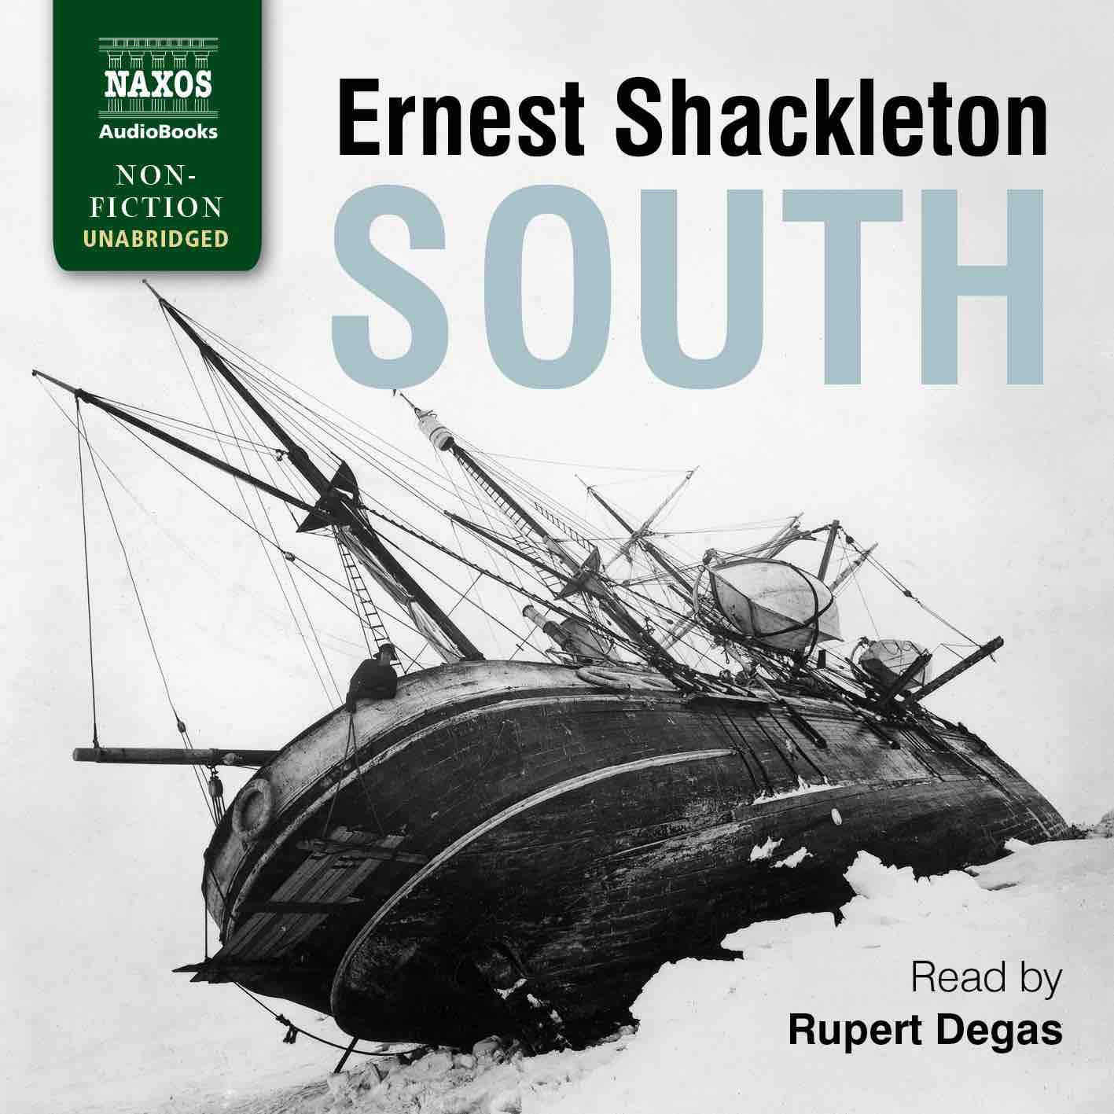

 | Cat No. | ISBN | Title | Hrs | Price | Author | Reader
 | NA0477 | 9781781983386 | THE WOMAN WHO SAVED THE CHILDREN | 14 | $37.00 | Clare Mulley | Joely Richardson
Jan | NA0400 | 9781781982440 | TWO ON A TOWER | 10 | $29.00 | Thomas Hardy | Leighton Pugh
 | NA0401 | 9781781982464 | SOUTH | 16 | $39.00 | Ernest Shackleton | Rupert Degas
 | NA0402 | 9781781982488 | THE PROFESSOR | 11.5 | $31.00 | Charlotte Brontë | Roger May
 | NA0403 | 9781781982501 | THE HAUNTED HOTEL | 6.75 | $21.50 | Wilkie Collins | Jonathan Keeble
 | NA0476 | 9781781983362 | AT SWIM-TWO-BIRDS | 8.25 | $25.00 | Flann O’Brien | Aidan Kelly
Feb | NA0404 | 9781781982525 | RODERICK HUDSON | 14 | $37.00 | Henry James | Adam Sims
 | NA0405 | 9781781982549 | THE INTERIOR CASTLE | 6.25 | $21.50 | St Teresa of Ávila | Lucy Scott
Mar | NA0406 | 9781781982563 | THE FEMALE QUIXOTE | 17.5 | $44.00 | Charlotte Lennox | Juliet Stevenson
 | NA0407 | 9781781982587 | THE WEALTH OF NATIONS | 40.5 | $85.00 | Adam Smith | Peter Wickham
 | NA0408 | 9781781982600 | THE HOUSE OF THE DEAD | 12 | $31.00 | Fyodor Dostoyevsky | Nicholas Boulton
 | NA0409 | 9781781982624 | ARMADALE | 30 | $67.00 | Wilkie Collins | Nicholas Boulton and cast
Apr | NA0410 | 9781781982648 | THE YOSEMITE | 7.5 | $25.00 | John Muir | Nick McArdle
 | NA0411 | 9781781982662 | ARSÈNE LUPIN, GENTLEMAN BURGLAR | 6.5 | $21.50 | Maurice Leblanc | David Timson
 | NA0412 | 9781781982686 | EFFI BRIEST | 10 | $27.00 | Theodor Fontane | Lucy Scott
May | NA0413 | 9781781982709 | A PHILOSOPHICAL ENQUIRY | 6 | $17.50 | Edmund Burke | Matt Addis
 | NA0414 | 9781781982723 | THE PERSIAN EXPEDITION | 9.25 | $27.00 | Xenophon | David Timson
 | NA0415 | 9781781982747 | NO NAME | 28 | $63.00 | Wilkie Collins | Nicholas Boulton and cast
Jun | NA0416 | 9781781982761 | THE BEAST IN THE JUNGLE | 2.25 | $9.50 | Henry James | Kris Dyer
 | NA0417 | 9781781982785 | THE MASTERPIECE | 15.5 | $39.00 | Émile Zola | Leighton Pugh

