N E W R E L E A S E I N F O R M A T I O N
J U L Y − D E C E M B E R 2 0 2 0

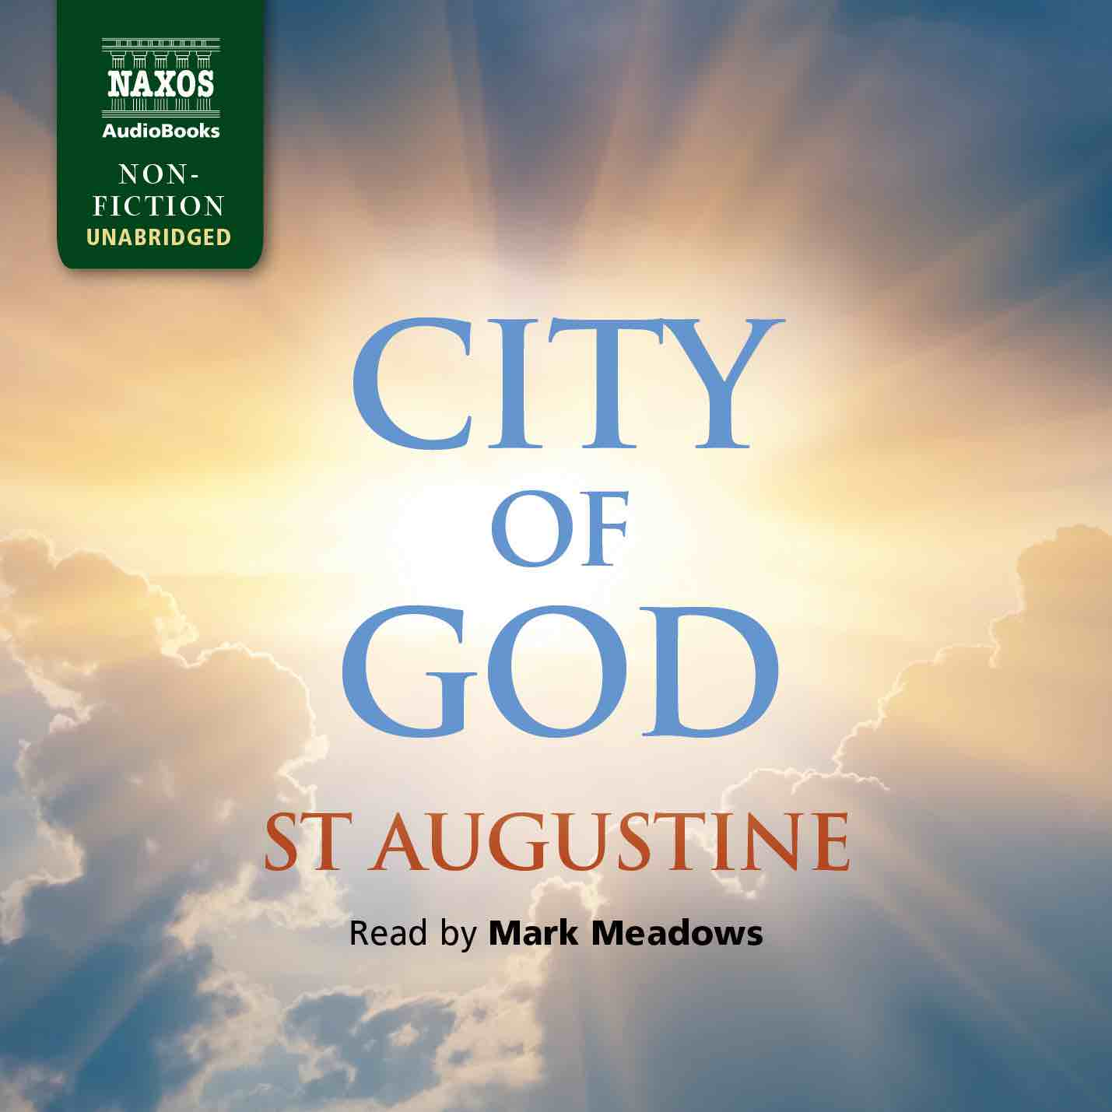
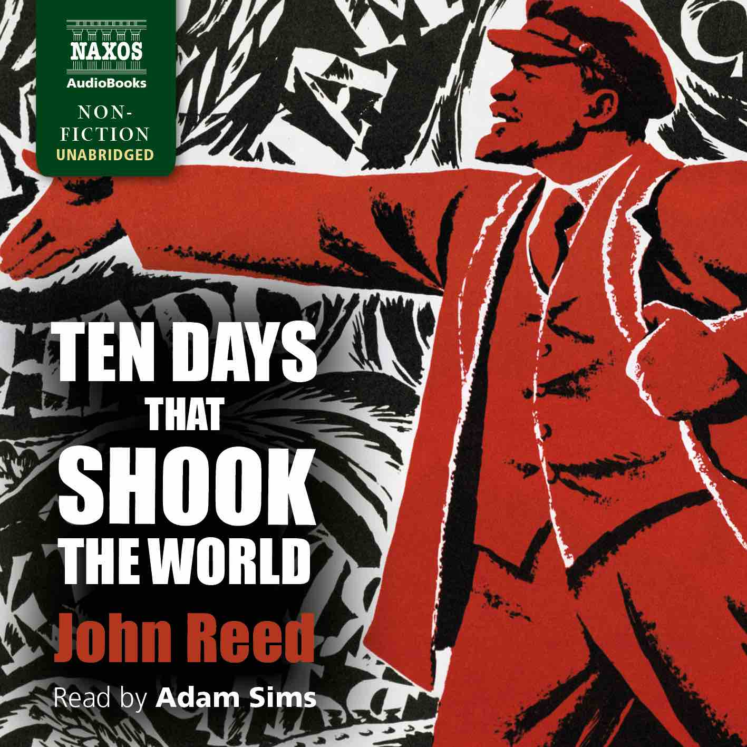
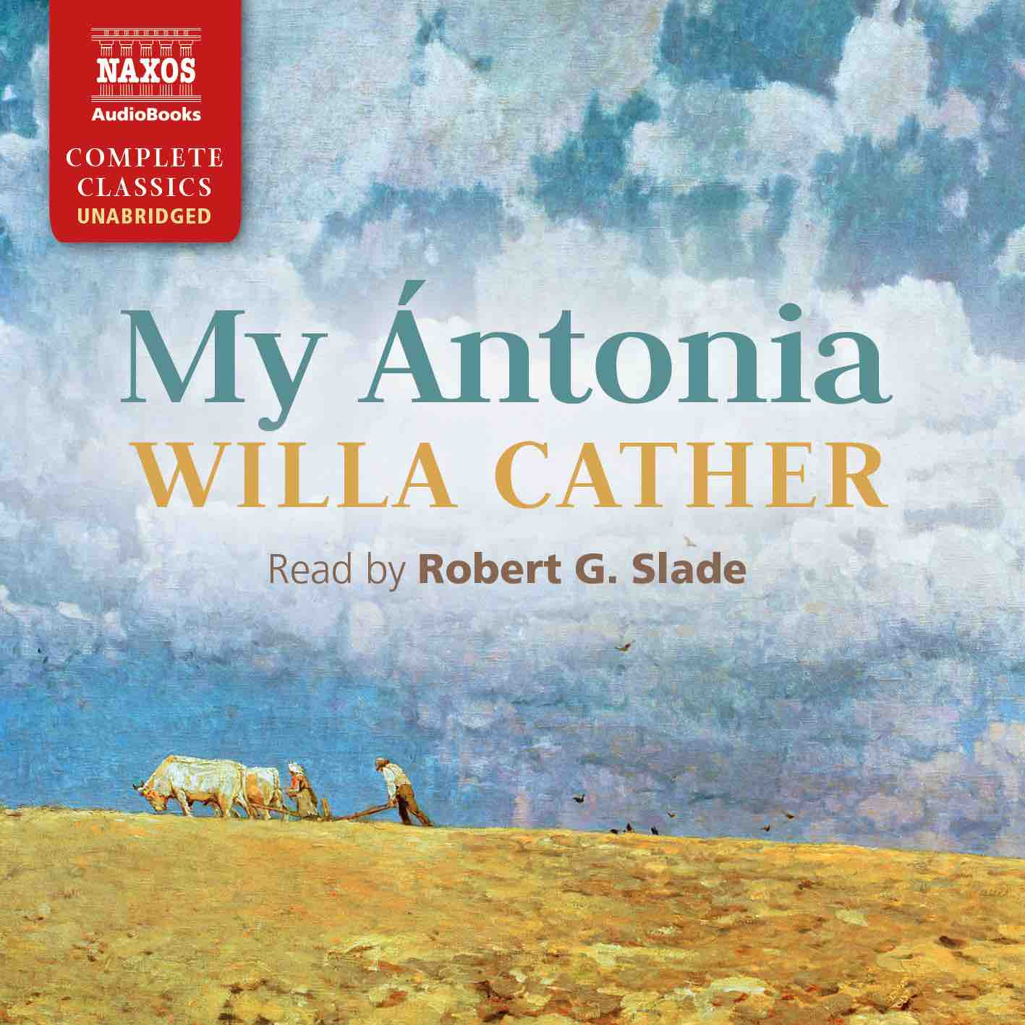

 | Cat No. | ISBN | Title | Hrs | Price | Author | Reader
July | NA0421 | 978-1-78198-203-7 | ETHAN FROME | 3.5 | £9.00 | Edith Wharton | Adam Sims
 | NA0456 | 978-1-78198-316-4 | THE BOOK OF THE CITY OF LADIES | 11.25 | £23.00 | Christine de Pizan | Georgina Sutton
 | NA0457 | 978-1-78198-317-1 | MY ÁNTONIA | 9 | £19.50 | Willa Cather | Robert G. Slade
 | NA0458 | 978-1-78198-318-8 | COUSIN BETTE | 16 | £29.00 | Honoré de Balzac | Lucy Scott
Aug | NA0461 | 978-1-78198-321-8 | THE LAST OF THE MOHICANS | 16.5 | £33.00 | James Fenimore Cooper | William Hope
 | NA0462 | 978-1-78198-322-5 | REFLECTIONS ON THE REVOLUTION IN FRANCE | 10.25 | £21.50 | Edmund Burke | Matt Addis
 | NA0472 | 978-1-78198-332-4 | DEMOCRACY IN AMERICA | 33.25 | £52.00 | Alexis de Tocqueville | Peter Wickham
Sep | NA0463 | 978-1-78198-323-2 | CITY OF GOD | 46.25 | £74.00 | St Augustine | Mark Meadows
 | NA0464 | 978-1-78198-324-9 | PIERS PLOWMAN | 9.75 | £19.50 | William Langland | Jonathan Keeble
 | NA0465 | 978-1-78198-325-6 | LA DAME AUX CAMÉLIAS | 6.75 | £16.00 | Maurice Leblanc | David Timson
 | NA0466 | 978-1-78198-326-3 | THE AMERICAN | 14.25 | £27.00 | Henry James | Adam Sims
Oct | NA0418 | 978-1-78198-280-8 | ARSÈNE LUPIN VERSUS HERLOCK SHOLMES | 7 | £16.00 | Maurice Leblanc | David Timson
 | NA0467 | 978-1-78198-327-0 | TEN DAYS THAT SHOOK THE WORLD | 9 | £19.50 | John Reed | Adam Sims
 | NA0468 | 978-1-78198-328-7 | CONFESSIONS | 29 | £49.00 | Jean-Jacques Rousseau | Jonathan Keeble
 | NA0469 | 978-1-78198-329-4 | ROMOLA | 23 | £39.00 | George Eliot | Lucy Scott
Nov | NA0470 | 978-1-78198-330-0 | THE AUTOBIOGRAPHY OF A HUNTED PRIEST | 7 | £16.00 | Father John Gerard | Gareth Armstrong
 | NA0471 | 978-1-78198-331-7 | LE MORTE D’ARTHUR | 39 | £62.00 | Sir Thomas Malory | Bill Homewood
 | NA0460 | 978-1-78198-320-1 | ANNALS | 17.5 | £33.00 | Tacitus | David Timson
Dec | NA0473 | 978-1-78198-333-1 | THE AUTOBIOGRAPHY OF ANDREW CARNEGIE AND THE GOSPEL OF WEALTH | 11. 5 | £23.00 | Andrew Carnegie | David Rintoul with Lucy Scott
 | NA0474 | 978-1-78198-334-8 | EMINENT VICTORIANS | 11.25 | £23.00 | Lytton Strachey | Jonathan Keeble
 | NA0475 | 978-1-78198-335-5 | SENTIMENTAL EDUCATION | 19 | £36.00 | Gustave Flaubert | TBC

