N E W R E L E A S E I N F O R M A T I O N
J U L Y − D E C E M B E R 2 0 2 0

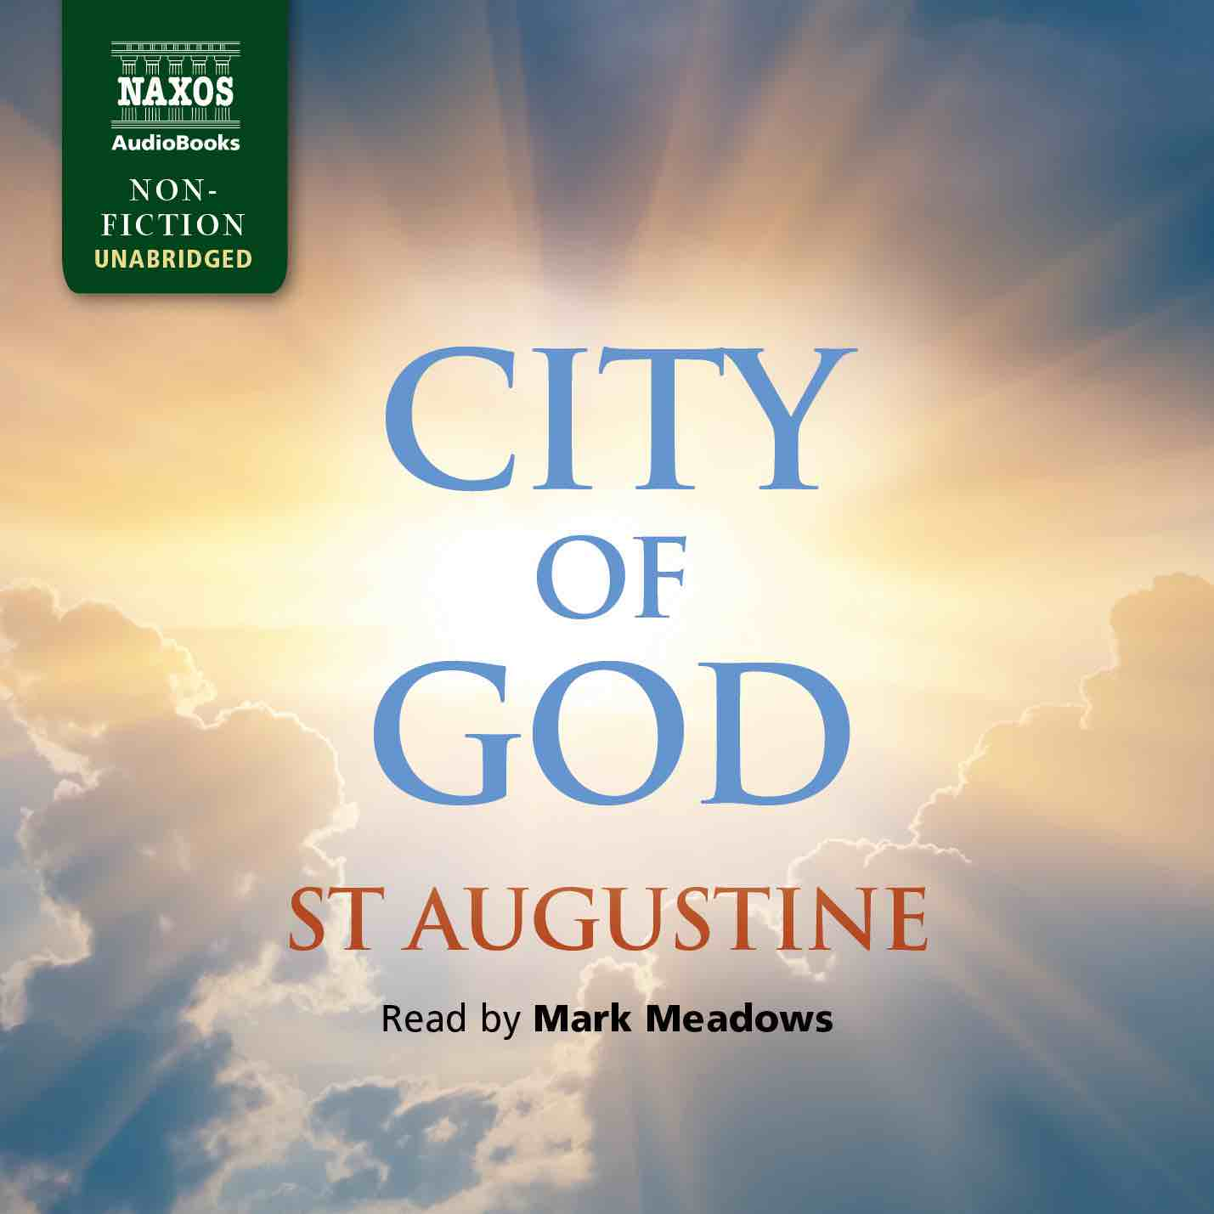
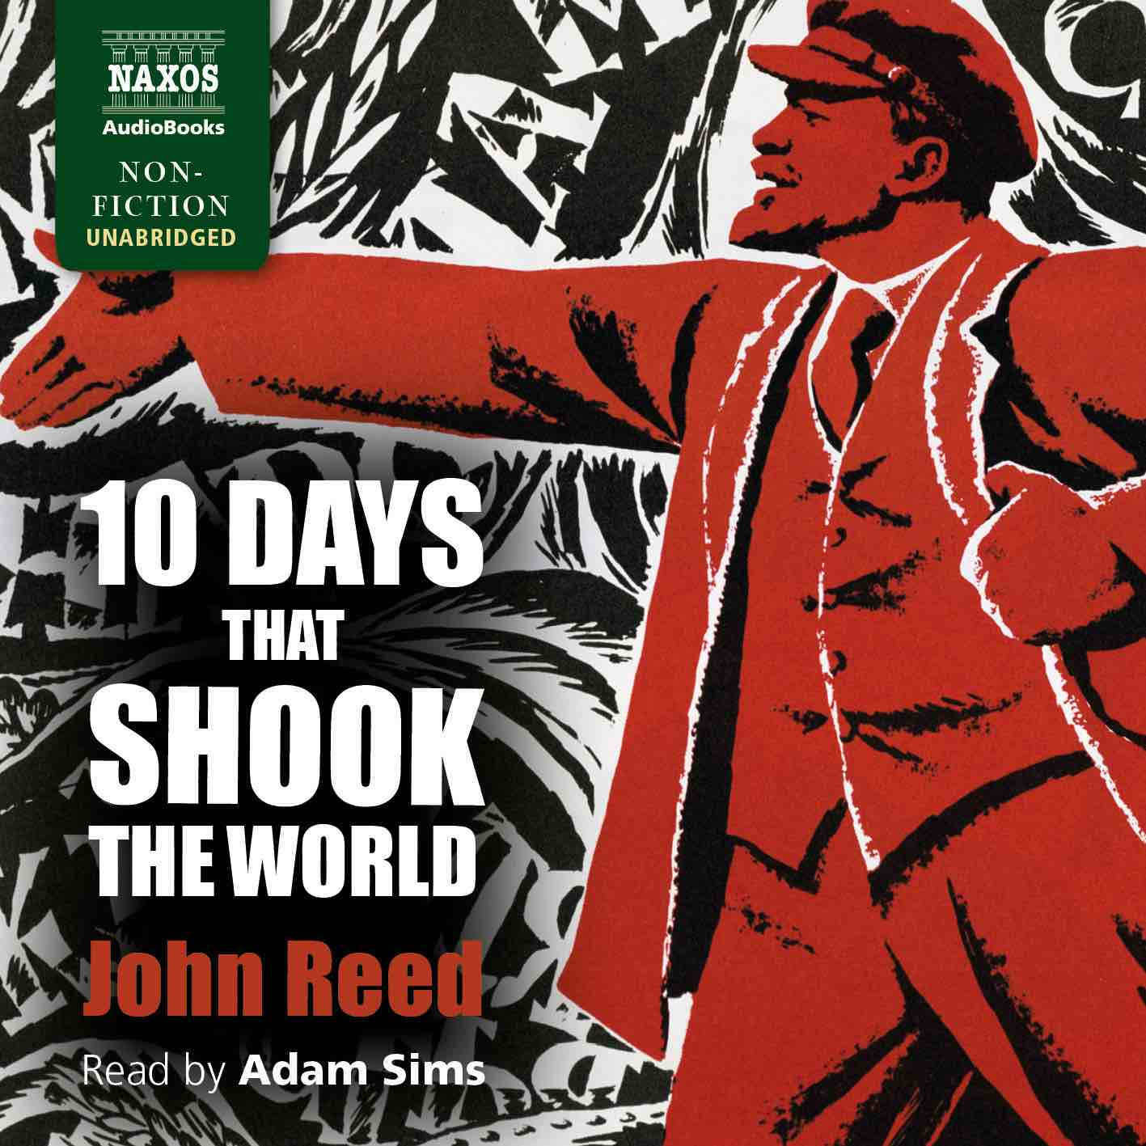
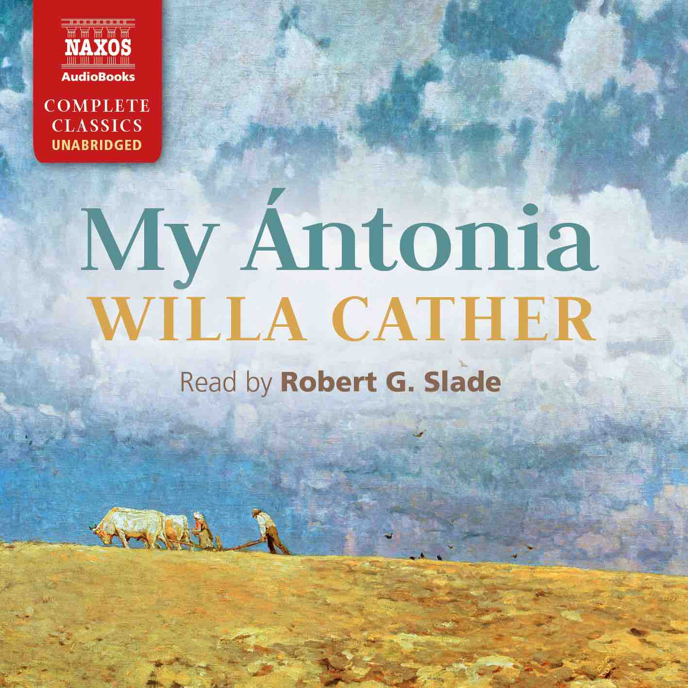

 | Cat No. | ISBN | Title | Hrs | Price | Author | Reader
July | NA0421 | 9781781982037 | ETHAN FROME | 3.5 | $12.00 | Edith Wharton | Adam Sims
 | NA0456 | 9781781983164 | THE BOOK OF THE CITY OF LADIES | 11.25 | $31.00 | Christine de Pizan | Georgina Sutton
 | NA0457 | 9781781983171 | MY ÁNTONIA | 9 | $27.00 | Willa Cather | Robert G. Slade
 | NA0458 | 9781781983188 | COUSIN BETTE | 16 | $39.00 | Honoré de Balzac | Lucy Scott
Aug | NA0461 | 9781781983218 | THE LAST OF THE MOHICANS | 16.5 | $44.00 | James Fenimore Cooper | William Hope
 | NA0462 | 9781781983225 | REFLECTIONS ON THE REVOLUTION IN FRANCE | 10.25 | $29.00 | Edmund Burke | Matt Addis
 | NA0472 | 9781781983324 | DEMOCRACY IN AMERICA | 33.25 | $71.00 | Alexis de Tocqueville | Peter Wickham
Sep | NA0463 | 9781781983232 | CITY OF GOD | 46.25 | $100.00 | St Augustine | Mark Meadows
 | NA0464 | 9781781983249 | PIERS PLOWMAN | 9.75 | $27.00 | William Langland | Jonathan Keeble
 | NA0465 | 9781781983256 | LA DAME AUX CAMÉLIAS | 6.75 | $21.50 | Alexandre Dumas Jr | Nicholas Bolton
 | NA0466 | 9781781983263 | THE AMERICAN | 14.25 | $37.00 | Henry James | Adam Sims
Oct | NA0418 | 9781781982808 | ARSÈNE LUPIN VERSUS HERLOCK SHOLMES | 7 | $21.50 | Maurice Leblanc | David Timson
 | NA0467 | 9781781983270 | TEN DAYS THAT SHOOK THE WORLD | 9 | $27.00 | John Reed | Adam Sims
 | NA0468 | 9781781983287 | CONFESSIONS | 29 | $67.00 | Jean-Jacques Rousseau | Jonathan Keeble
 | NA0469 | 9781781983294 | ROMOLA | 23 | $54.00 | George Eliot | Lucy Scott
Nov | NA0470 | 9781781983300 | THE AUTOBIOGRAPHY OF A HUNTED PRIEST | 7 | $21.50 | Father John Gerard | Gareth Armstrong
 | NA0471 | 9781781983317 | LE MORTE D’ARTHUR | 39 | $85.00 | Sir Thomas Malory | Bill Homewood
 | NA0460 | 9781781983201 | ANNALS | 17.5 | $44.00 | Tacitus | David Timson
Dec | NA0473 | 9781781983331 | THE AUTOBIOGRAPHY OF ANDREW CARNEGIE AND THE GOSPEL OF WEALTH | 11. 5 | $31.00 | Andrew Carnegie | David Rintoul with Lucy Scott
 | NA0474 | 9781781983348 | EMINENT VICTORIANS | 11.25 | $31.00 | Lytton Strachey | Jonathan Keeble
 | NA0475 | 9781781983355 | SENTIMENTAL EDUCATION | 19 | $49.00 | Gustave Flaubert | TBC

