N E W R E L E A S E I N F O R M A T I O N

J A N U A R Y − J U N E 2 0 2 1



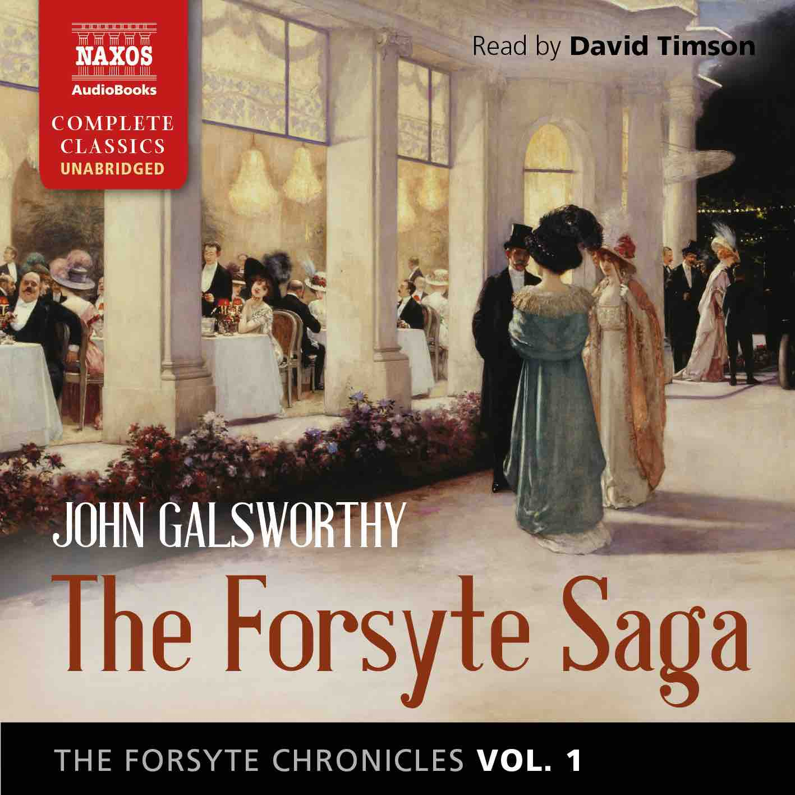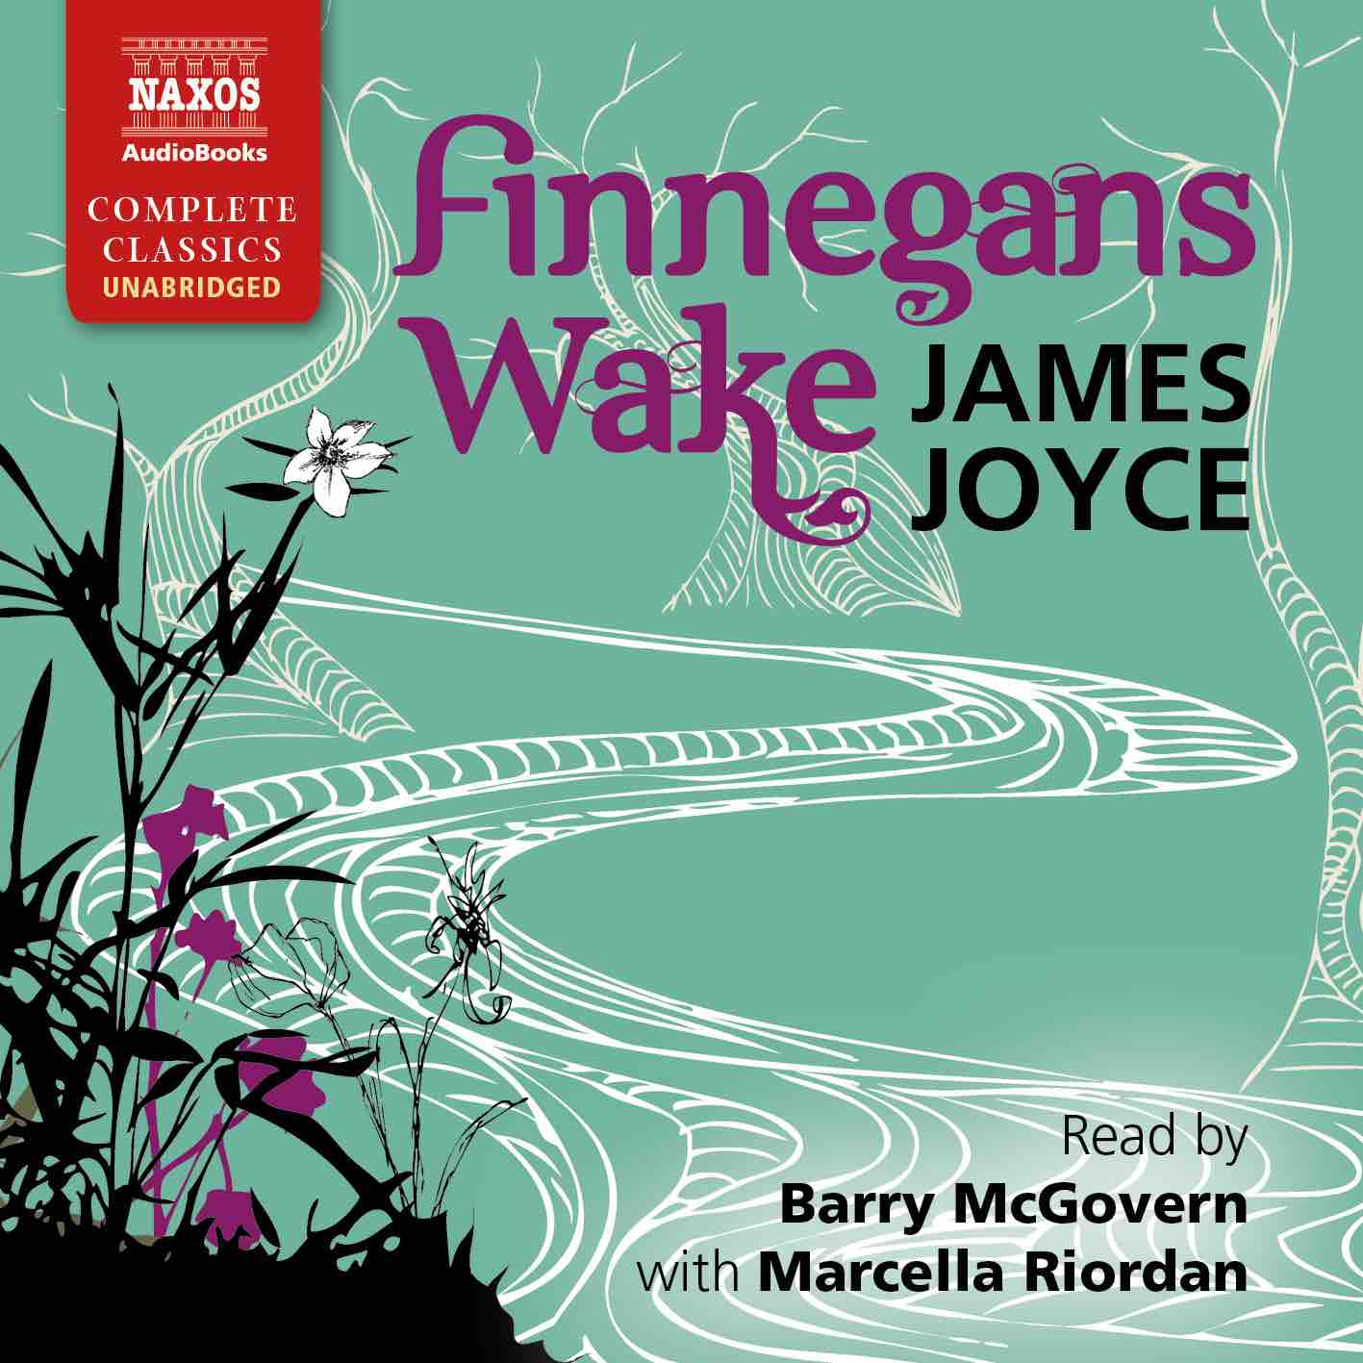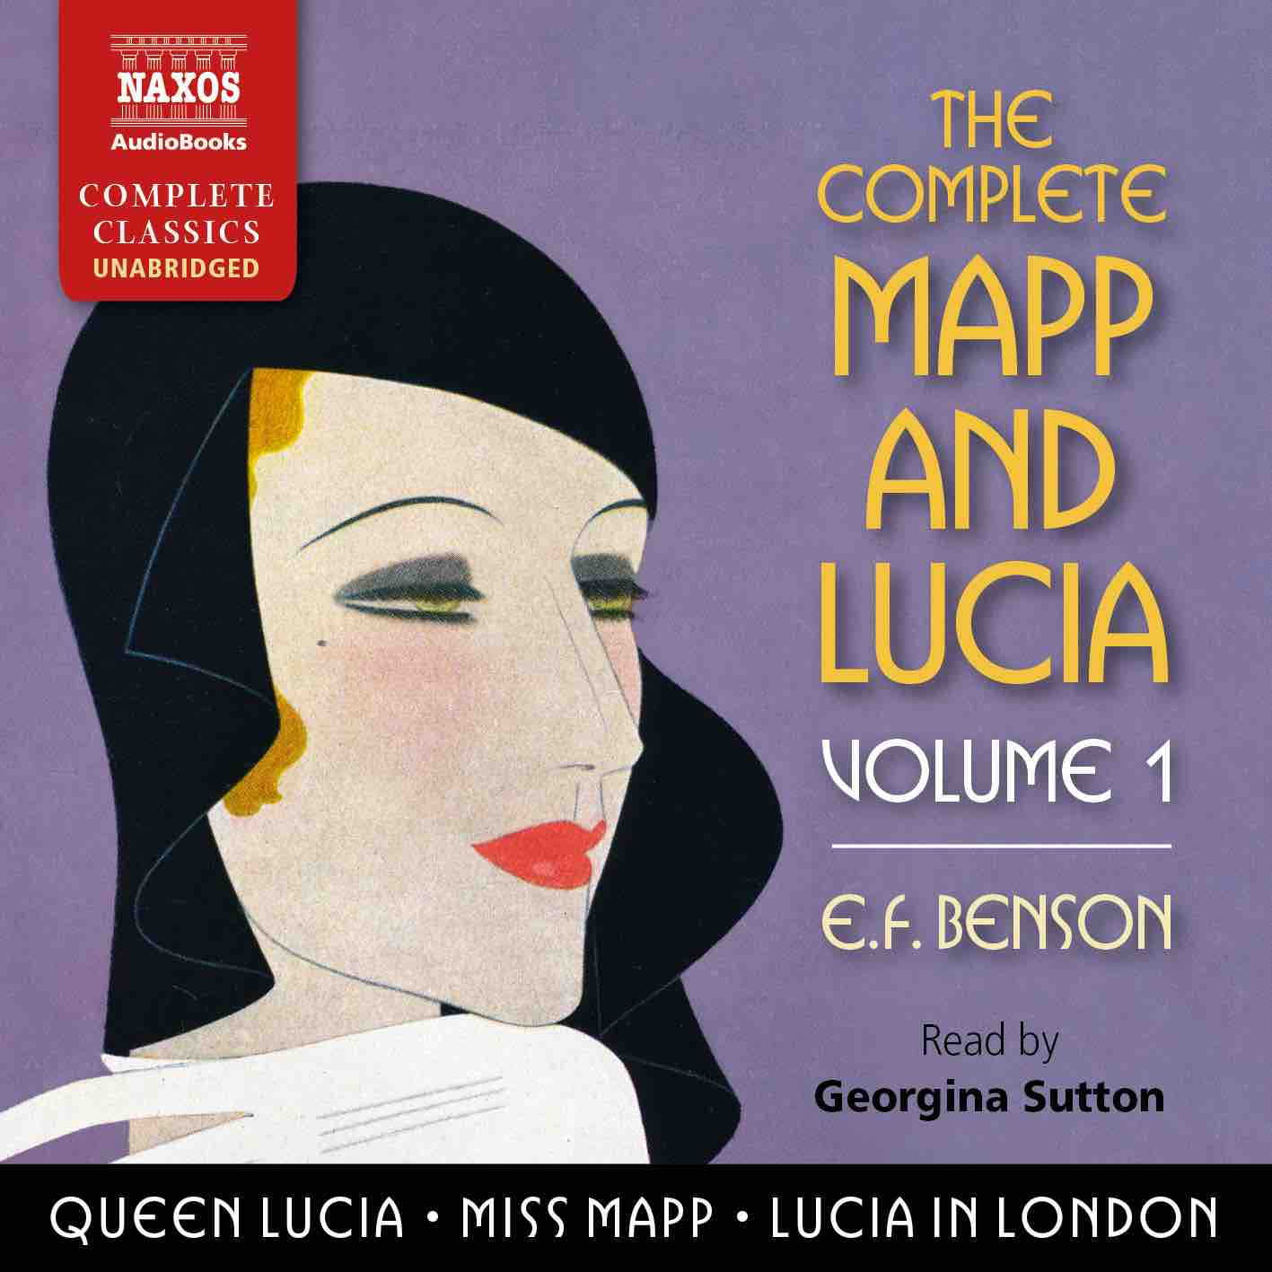

|  |  |  |  |  |  |  |  |
| --- | --- | --- | --- | --- | --- | --- | --- |
|  | Cat No. | ISBN | Title | Hrs | Price | Author | Reader |
| Jan | NA0495 | 978-1-78198-357-7 | **THE DEAD SECRET** | 13.25 | £25.00 | Wilkie Collins | Nicholas Boulton |
|  | NA0489 | 978-1-78198-351-5 | **THE DESCENT OF MAN** | 27.25 | £46.00 | Charles Darwin | Peter Wickham |
|  | NA0480 | 978-1-78198-342-3 | **THE DARK NIGHT OF THE SOUL** | 5.5 | £13.00 | St John of the Cross | Peter Wickham |
| Feb | NA0481 | 978-1-78198-343-0 | **THE WELL-BELOVED** | 6.5 | £16.00 | Thomas Hardy | Leighton Pugh |
|  | NA0482 | 978-1-78198-344-7 | **THE FORSYTE CHRONICLES, VOLUME 1** | 36 | £55.00 | John Galsworthy | David Timson |
|  | NA0485 | 978-1-78198-347-8 | **THE SPOILS OF POYNTON** | 8 | £18.00 | Henry James | Juliet Stevenson |
|  | NA0500 | 978-1-78198-363-8 | **THE ENCHEIRIDION AND DISCOURSES** | 12.25 | £23.00 | Epictetus | Jonathan Booth |
| Mar | NA0488 | 978-1-78198-350-8 | **THE ODD WOMEN** | 17 | £33.00 | George Gissing | Juliet Stevenson |
|  | NA0496 | 978-1-78198-359-1 | **THE COMPLETE MAPP AND LUCIA, VOLUME 1** | 29.25 | £49.00 | E.F. Benson | Georgina Sutton |
|  | NA0487 | 978-1-78198-349-2 | **THE ADVENTURES OF RODERICK RANDOM** | 17.75 | £33.00 | Tobias Smollett | Peter Kenny |
|  | NA0479 | 978-1-78198-341-6 | **DIALOGUES AND THE NATURAL HISTORY OF RELIGION** | 6 | £13.00 | David Hume | Hugh Ross |
| Apr | NA0505 | 978-1-78198-368-3 | **THE FORSYTE CHRONICLES, VOLUME 2** | 32 | £52.00 | John Galsworthy | David Timson |
|  | NA0501 | 978-1-78198-364-5 | **THE ISLAND OF DOCTOR MOREAU** | 4.5 | £11.00 | H.G. Wells | Jonathan Keeble |
|  | NA0507 | 978-1-78198-370-6 | **THE MASTER OF BALLANTRAE** | 9.25 | £19.50 | Robert Louis Stevenson | David Rintoul |
| May | NA0484 | 978-1-78198-346-1 | **ON THE HAPPY LIFE – THE COMPLETE DIALOGUES** | 14.5 | £27.00 | Seneca | Ric Jerrom |
|  | NA0497 | 978-1-78198-360-7 | **THE COMPLETE MAPP AND LUCIA, VOLUME 2** | 31 | £49.00 | E.F. Benson | Georgina Sutton |
|  | NA0504 | 978-1-78198-367-6 | **EAST LYNNE** | 23.5 | £39.00 | Ellen Wood | Rachel Atkins |
|  | NA0493 | 978-1-78198-355-3 | **LA BÊTE HUMAINE** | 15.5 | £29.00 | Émile Zola | Leighton Pugh |
| Jun | NA0494 | 978-1-78198-356-0 | **THE HISTORIES** | 10.75 | £21.50 | Tacitus | David Timson |
|  | NA0503 | 978-1-78198-366-9 | **FINNEGANS WAKE** | 24 | £42.00 | James Joyce | Barry McGovern with Marcella Riordan |
|  | NA0506 | 978-1-78198-369-0 | **THE FORSYTE CHRONICLES, VOLUME 3** | 29.5 | £49.00 | John Galsworthy | David Timson |
|  | NA0502 | 978-1-78198-365-2 | **THE COMPLETE SHORT STORIES** | 22 | £39.00 | Saki | Rupert Degas |