N E W R E L E A S E I N F O R M A T I O N
J A N U A R Y − J U N E 2 0 2 1

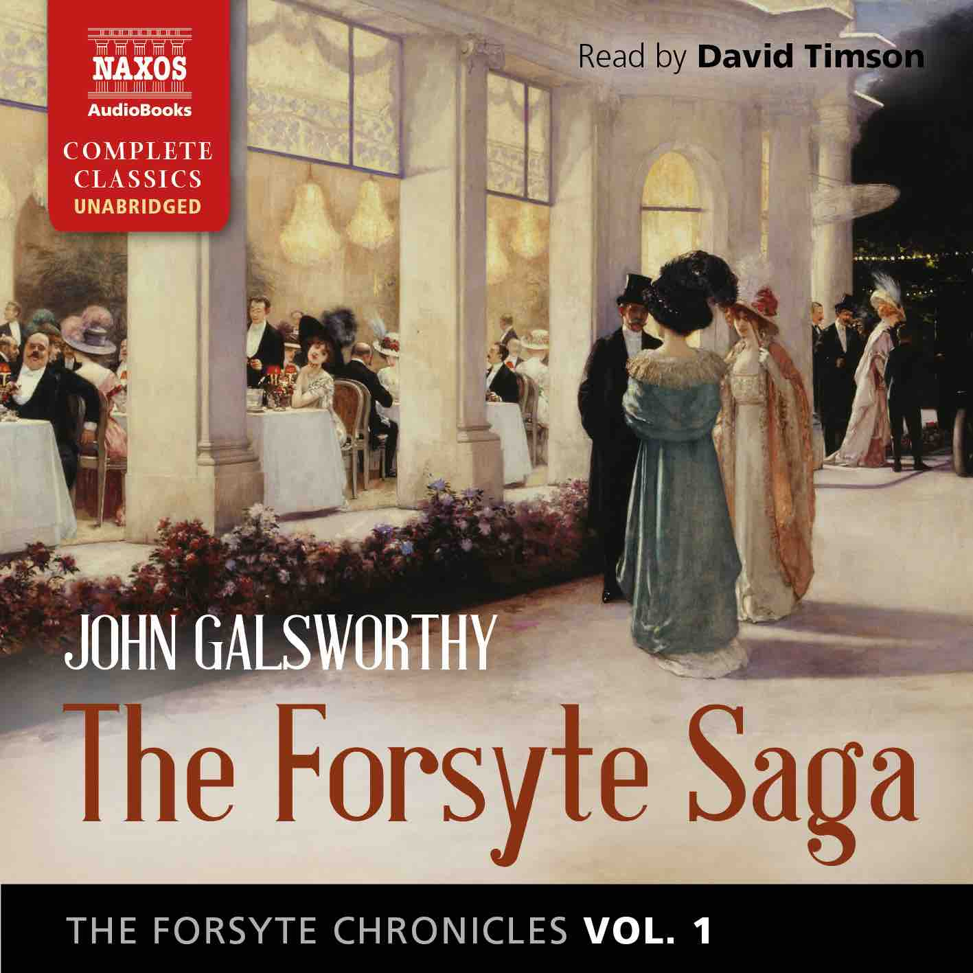
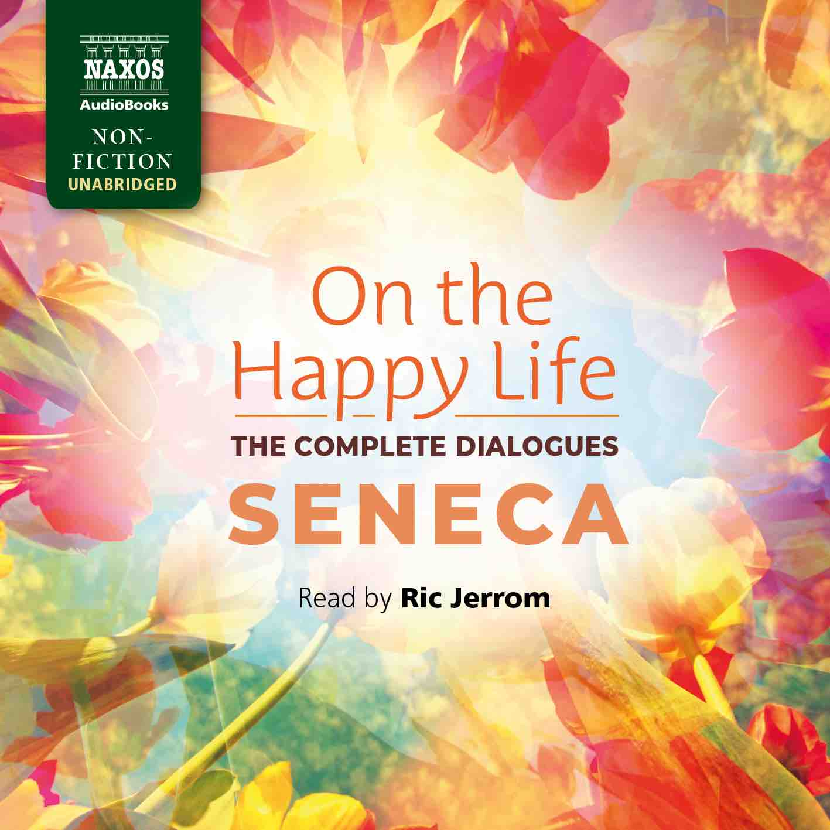
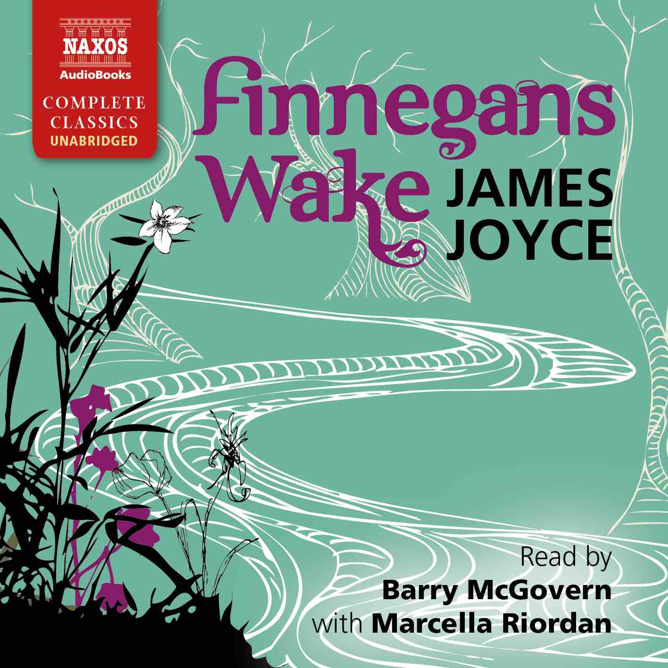
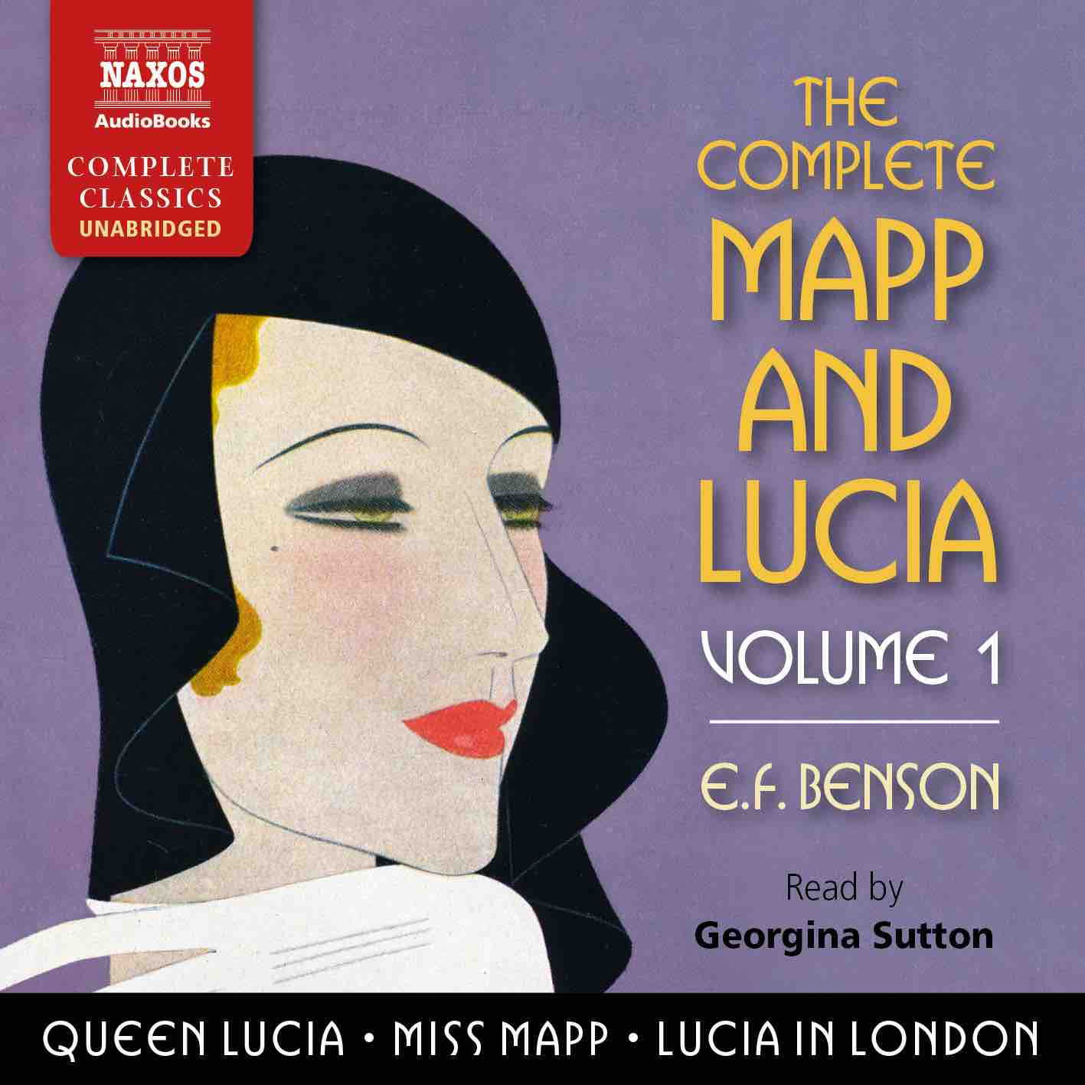

 | Cat No. | ISBN | Title | Hrs | Price | Author | Reader
Jan | NA0495 | 9781781983577 | THE DEAD SECRET | 13.25 | $34.00 | Wilkie Collins | Nicholas Boulton
 | NA0489 | 9781781983515 | THE DESCENT OF MAN | 27.25 | $63.00 | Charles Darwin | Peter Wickham
 | NA0480 | 9781781983423 | THE DARK NIGHT OF THE SOUL | 5.5 | $17.50 | St John of the Cross | Peter Wickham
Feb | NA0481 | 9781781983430 | THE WELL-BELOVED | 6.5 | $21.50 | Thomas Hardy | Leighton Pugh
 | NA0482 | 9781781983447 | THE FORSYTE CHRONICLES, VOLUME 1 | 36 | $75.00 | John Galsworthy | David Timson
 | NA0485 | 9781781983478 | THE SPOILS OF POYNTON | 8 | $25.00 | Henry James | Juliet Stevenson
 | NA0500 | 9781781983638 | THE ENCHEIRIDION AND DISCOURSES | 12.25 | $31.00 | Epictetus | Jonathan Booth
Mar | NA0488 | 9781781983508 | THE ODD WOMEN | 17 | $44.00 | George Gissing | Juliet Stevenson
 | NA0496 | 9781781983591 | THE COMPLETE MAPP AND LUCIA, VOLUME 1 | 29.25 | $67.00 | E.F. Benson | Georgina Sutton
 | NA0487 | 9781781983492 | THE ADVENTURES OF RODERICK RANDOM | 17.75 | $44.00 | Tobias Smollett | Peter Kenny
 | NA0479 | 9781781983416 | DIALOGUES AND THE NATURAL HISTORY OF RELIGION | 6 | $17.50 | David Hume | Hugh Ross
Apr | NA0505 | 9781781983683 | THE FORSYTE CHRONICLES, VOLUME 2 | 32 | $71.00 | John Galsworthy | David Timson
 | NA0501 | 9781781983645 | THE ISLAND OF DOCTOR MOREAU | 4.5 | $15.00 | H.G. Wells | Jonathan Keeble
 | NA0507 | 9781781983706 | THE MASTER OF BALLANTRAE | 9.25 | $27.00 | Robert Louis Stevenson | David Rintoul
May | NA0484 | 9781781983461 | ON THE HAPPY LIFE – THE COMPLETE DIALOGUES | 14.5 | $37.00 | Seneca | Ric Jerrom
 | NA0497 | 9781781983607 | THE COMPLETE MAPP AND LUCIA, VOLUME 2 | 31 | $67.00 | E.F. Benson | Georgina Sutton
 | NA0504 | 9781781983676 | EAST LYNNE | 23.5 | $54.00 | Ellen Wood | Rachel Atkins
 | NA0493 | 9781781983553 | LA BÊTE HUMAINE | 15.5 | $39.00 | Émile Zola | Leighton Pugh
Jun | NA0494 | 9781781983560 | THE HISTORIES | 10.75 | $29.00 | Tacitus | David Timson
 | NA0503 | 9781781983669 | FINNEGANS WAKE | 24 | $58.00 | James Joyce | Barry McGovern with Marcella Riordan
 | NA0506 | 9781781983690 | THE FORSYTE CHRONICLES, VOLUME 3 | 29.5 | $67.00 | John Galsworthy | David Timson
 | NA0502 | 9781781983652 | THE COMPLETE SHORT STORIES | 22 | $54.00 | Saki | Rupert Degas

