N E W R E L E A S E I N F O R M A T I O N
J A N U A R Y − J U N E 2 0 2 1

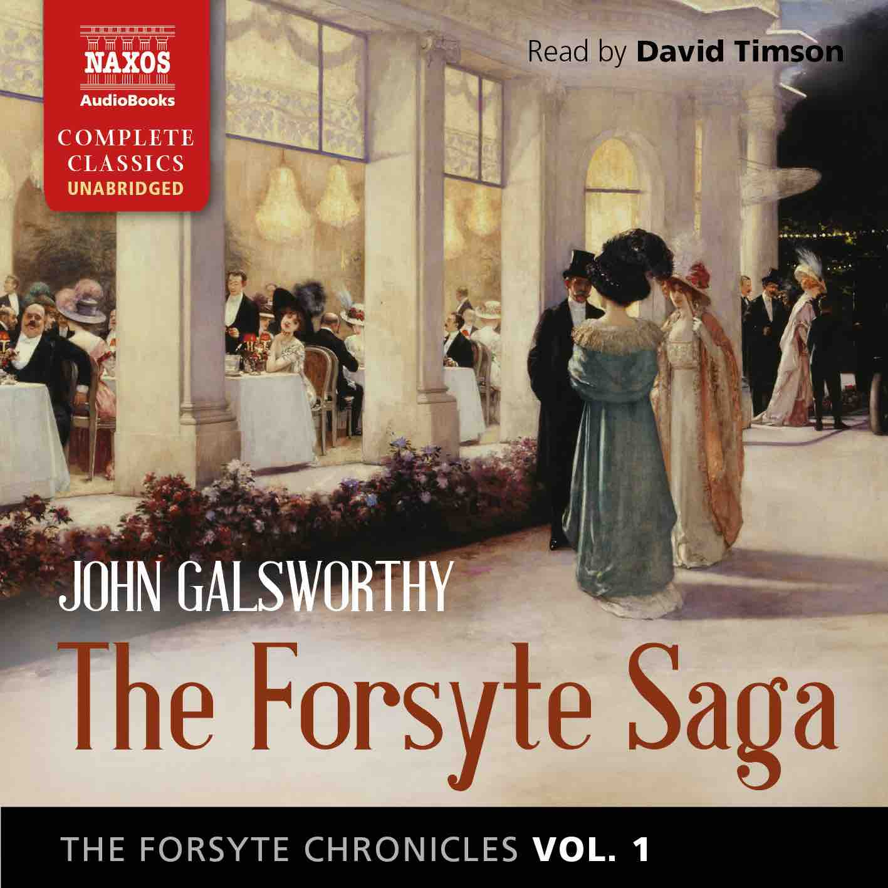
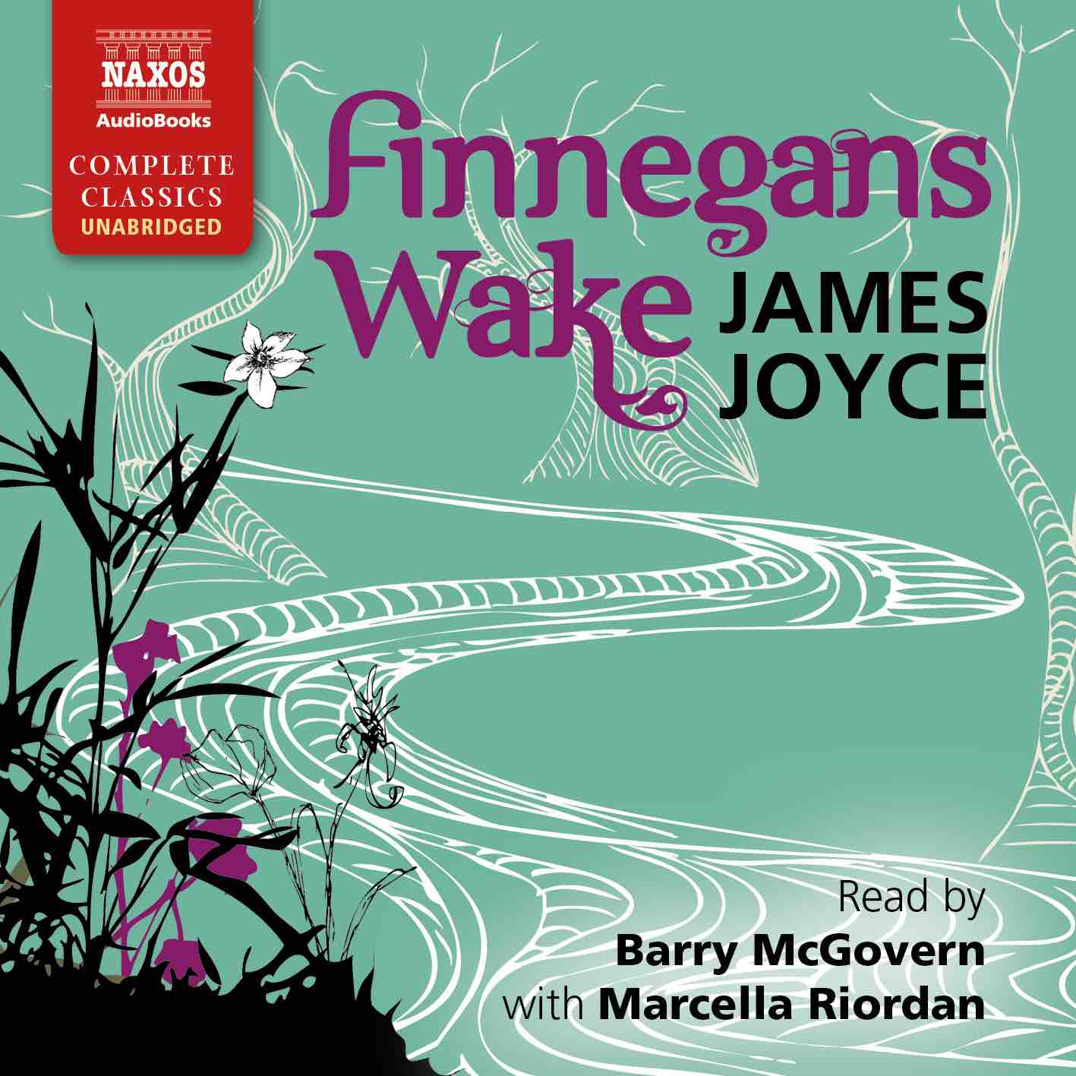
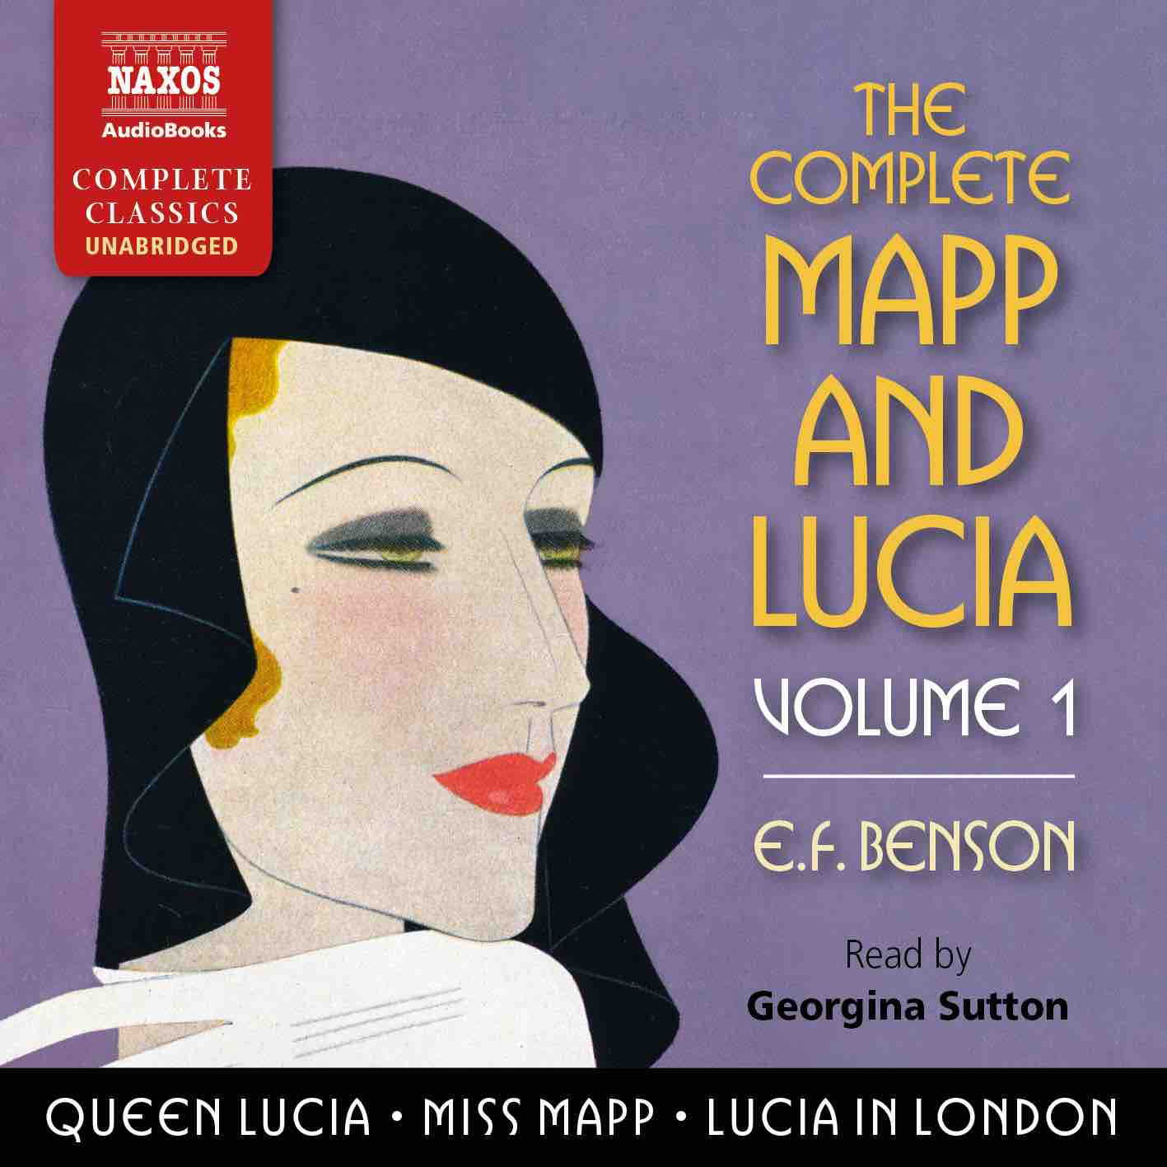

 | Cat No. | ISBN | Title | Hrs | Price | Author | Reader
Jan | NA0495 | 978-1-78198-357-7 | THE DEAD SECRET | 13.25 | £25.00 | Wilkie Collins | Nicholas Boulton
 | NA0489 | 978-1-78198-351-5 | THE DESCENT OF MAN | 27.25 | £46.00 | Charles Darwin | Peter Wickham
 | NA0480 | 978-1-78198-342-3 | THE DARK NIGHT OF THE SOUL | 5.5 | £13.00 | St John of the Cross | Peter Wickham
Feb | NA0481 | 978-1-78198-343-0 | THE WELL-BELOVED | 6.5 | £16.00 | Thomas Hardy | Leighton Pugh
 | NA0482 | 978-1-78198-344-7 | THE FORSYTE CHRONICLES, VOLUME 1 | 38 | £59.00 | John Galsworthy | David Timson
 | NA0485 | 978-1-78198-347-8 | THE SPOILS OF POYNTON | 8 | £18.00 | Henry James | Juliet Stevenson
 | NA0500 | 978-1-78198-363-8 | THE ENCHEIRIDION AND DISCOURSES | 12.25 | £23.00 | Epictetus | Jonathan Booth
Mar | NA0488 | 978-1-78198-350-8 | THE ODD WOMEN | 17 | £33.00 | George Gissing | Juliet Stevenson
 | NA0496 | 978-1-78198-359-1 | THE COMPLETE MAPP AND LUCIA, VOLUME 1 | 26.75 | £46.00 | E.F. Benson | Georgina Sutton
 | NA0487 | 978-1-78198-349-2 | THE ADVENTURES OF RODERICK RANDOM | 17.75 | £33.00 | Tobias Smollett | Peter Kenny
 | NA0479 | 978-1-78198-341-6 | DIALOGUES AND THE NATURAL HISTORY OF RELIGION | 7 | £16.00 | David Hume | Hugh Ross
 | NA0508 | 978-1-78198-372-0 | MACHIAVELLI: HIS LIFE AND TIMES | 23 | £39.00 | Alexander Lee | Jonathan Keeble
Apr | NA0505 | 978-1-78198-368-3 | THE FORSYTE CHRONICLES, VOLUME 2 | 34.5 | £55.00 | John Galsworthy | David Timson
 | NA0501 | 978-1-78198-364-5 | THE ISLAND OF DOCTOR MOREAU | 4.5 | £11.00 | H.G. Wells | Jonathan Keeble
 | NA0507 | 978-1-78198-370-6 | THE MASTER OF BALLANTRAE | 9.25 | £19.50 | Robert Louis Stevenson | David Rintoul
May | NA0484 | 978-1-78198-346-1 | ON THE HAPPY LIFE – THE COMPLETE DIALOGUES | 14.5 | £27.00 | Seneca | Ric Jerrom
 | NA0497 | 978-1-78198-360-7 | THE COMPLETE MAPP AND LUCIA, VOLUME 2 | 28 | £46.00 | E.F. Benson | Georgina Sutton
 | NA0504 | 978-1-78198-367-6 | EAST LYNNE | 23.5 | £39.00 | Ellen Wood | Rachel Atkins
 | NA0493 | 978-1-78198-355-3 | LA BÊTE HUMAINE | 15.5 | £29.00 | Émile Zola | Leighton Pugh
Jun | NA0494 | 978-1-78198-356-0 | THE HISTORIES | 10.75 | £21.50 | Tacitus | David Timson
 | NA0503 | 978-1-78198-366-9 | FINNEGANS WAKE | 24 | £42.00 | James Joyce | Barry McGovern with Marcella Riordan
 | NA0506 | 978-1-78198-369-0 | THE FORSYTE CHRONICLES, VOLUME 3 | 31 | £49.00 | John Galsworthy | David Timson
 | NA0502 | 978-1-78198-365-2 | THE COMPLETE SHORT STORIES | 22 | £39.00 | Saki | Rupert Degas

