N E W R E L E A S E I N F O R M A T I O N
J U L Y − D E C E M B E R 2 0 2 1

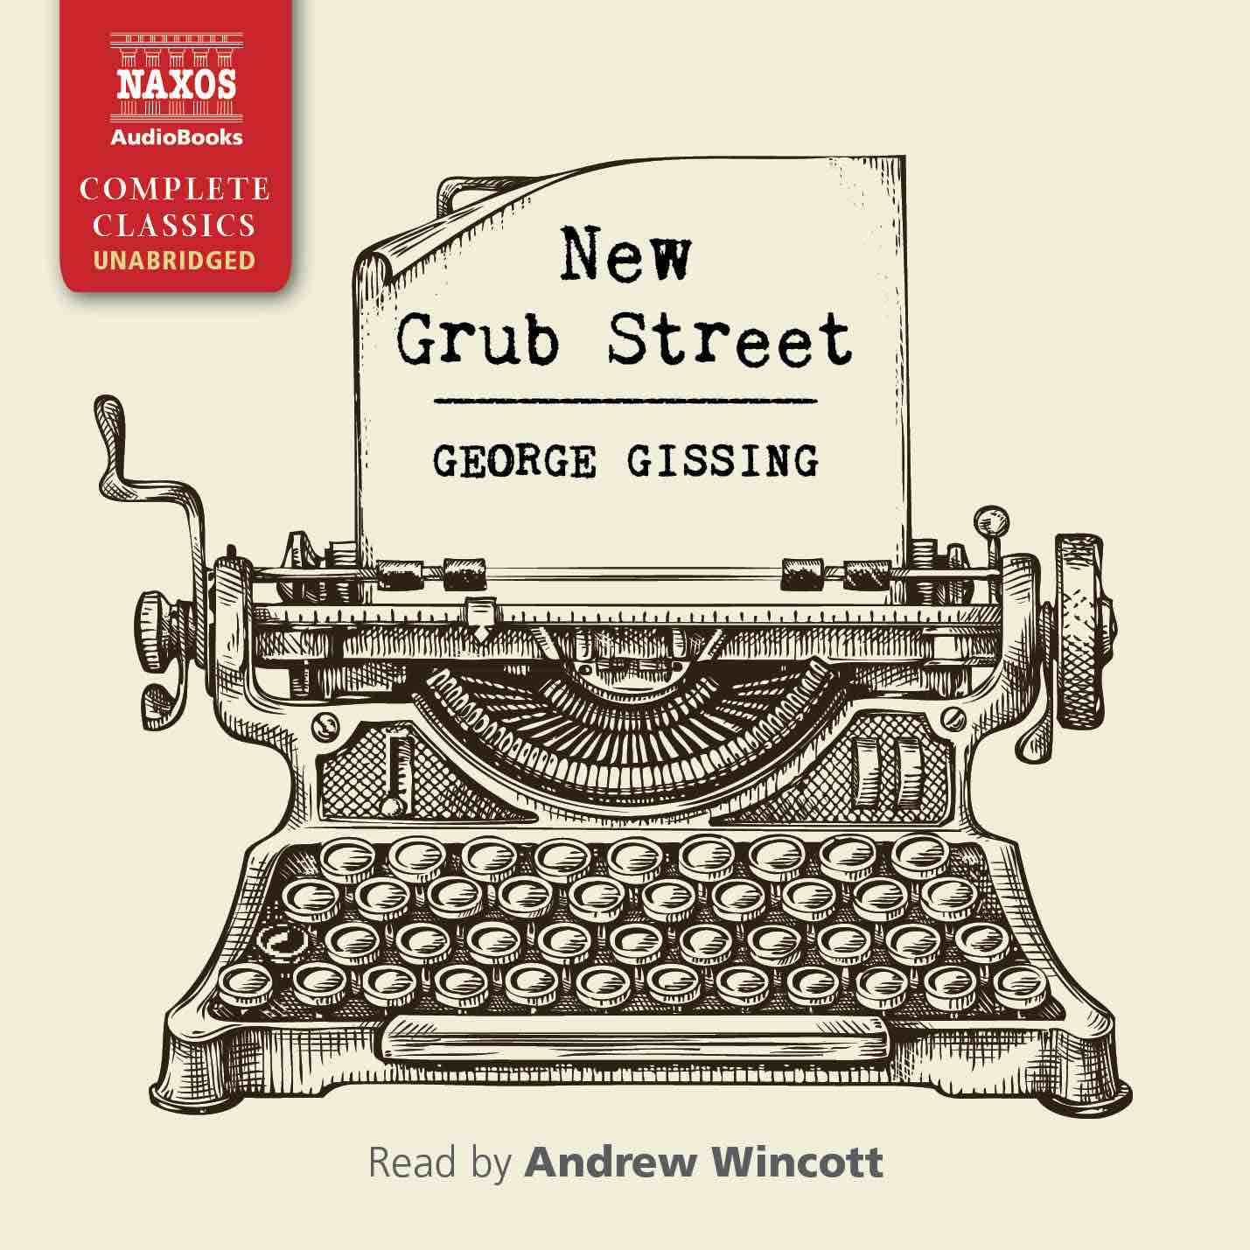
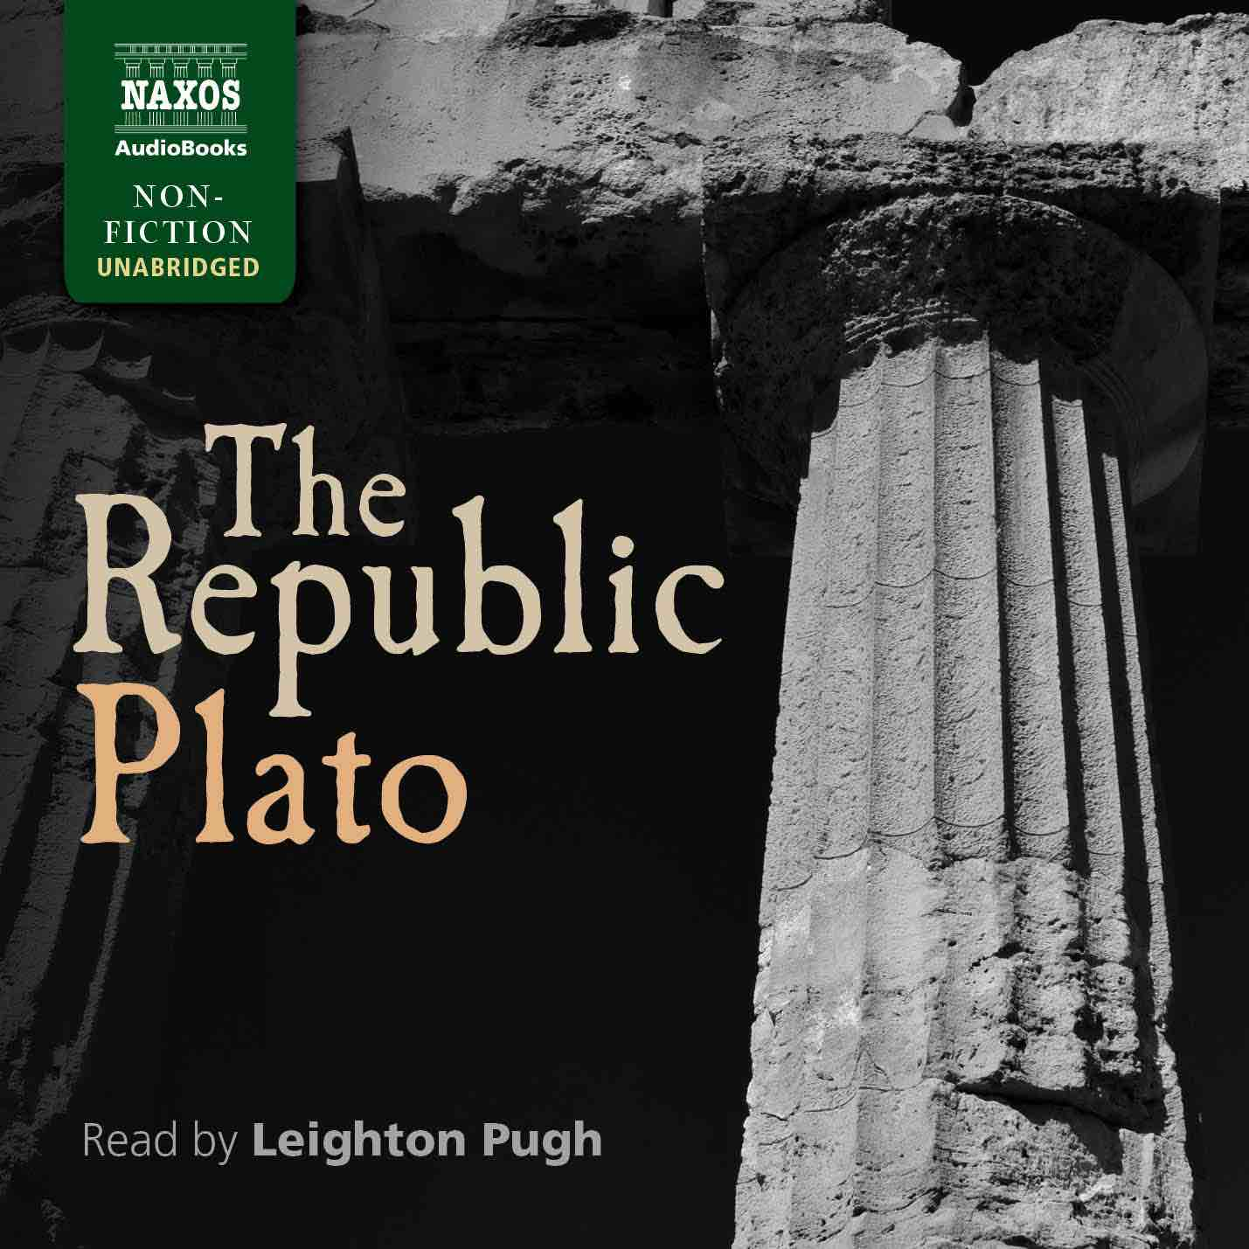
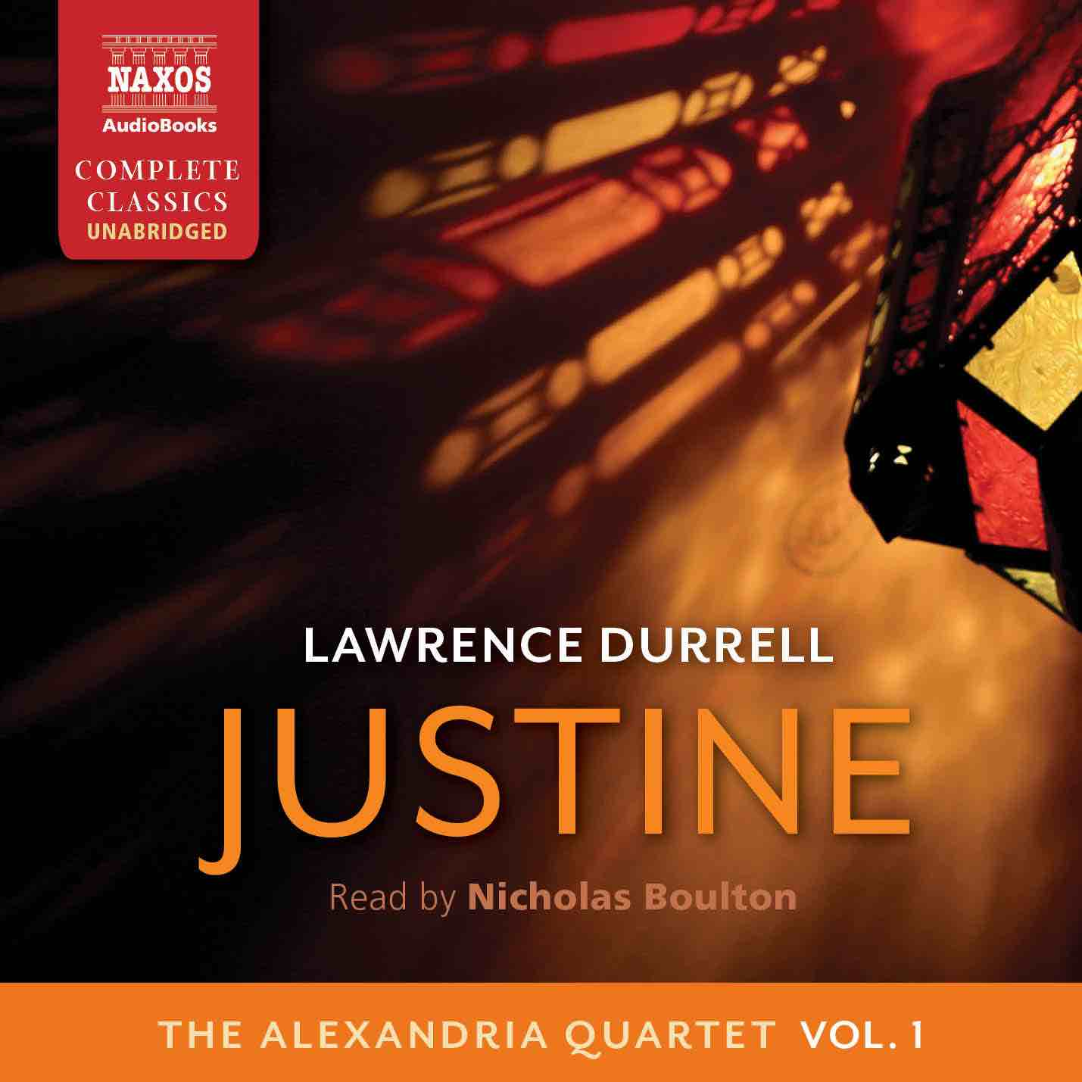
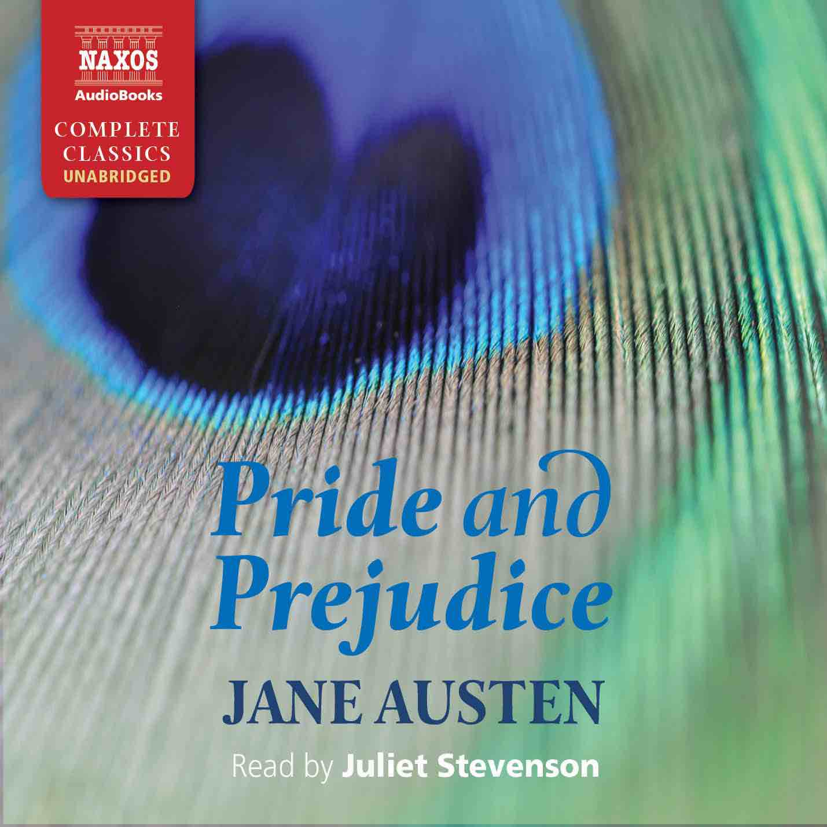

 | Cat No. | ISBN | Title | Hrs | Price | Author | Reader
Jul | NA0478 | 9781781983409 | PARZIVAL | 18.25 | $44.00 | Wolfram von Eschenbach | Leighton Pugh
 | NA0510 | 9781781983744 | THE IMITATION OF CHRIST | 6 | $17.50 | Thomas à Kempis | Jonathan Booth
 | NA0511 | 9781781983751 | PRIDE AND PREJUDICE | 14 | $37.00 | Jane Austen | Juliet Stevenson
Aug | NA0512 | 9781781983768 | COLONEL CHABERT | 3 | $12.00 | Honoré de Balzac | Bill Homewood
 | NA0509 | 9781781983737 | MAN AND WIFE | 23 | $54.00 | Wilkie Collins | Nicholas Boulton
 | NA0516 | 9781781983805 | MY CHILDHOOD | 8.5 | $25.00 | Maxim Gorky | Nicholas Boulton
 | NA0522 | 9781781983867 | JUSTINE | 8.75 | $27.00 | Lawrence Durrell | Nicholas Boulton
 | NA0523 | 9781781983874 | BALTHAZAR | 8.5 | $25.00 | Lawrence Durrell | Nicholas Boulton
 | NA0524 | 9781781983881 | MOUNTOLIVE | 11.5 | $31.00 | Lawrence Durrell | Nicholas Boulton
 | NA0525 | 9781781983898 | CLEA | 10.5 | $29.00 | Lawrence Durrell | Nicholas Boulton
Sep | NA0492 | 9781781983546 | ZOFLOYA | 11.5 | $31.00 | Charlotte Dacre | Lucy Scott
 | NA0486 | 9781781983485 | ON WAR | 29 | $67.00 | Carl von Clausewitz | David Timson
 | NA0515 | 9781781983799 | BEAU GESTE | 14 | $37.00 | P.C. Wren | Rupert Degas
 | NA0490 | 9781781983522 | MY BONDAGE AND MY FREEDOM | 13.5 | $34.00 | Frederick Douglass | Leon Nixon
Oct | NA0491 | 9781781983539 | THE COMPLETE ESSAYS | 53 | $110.00 | Michel de Montaigne | Peter Wickham
 | NA0517 | 9781781983812 | THE REPUBLIC | 12.75 | $34.00 | Plato | Leighton Pugh
Nov | NA0518 | 9781781983829 | THE LADIES’ PARADISE | 18 | $44.00 | Émile Zola | Leighton Pugh
 | NA0520 | 9781781983843 | QUO VADIS | 21 | $49.00 | Henryk Sienkiewicz | Peter Wickham
Dec | NA0521 | 9781781983850 | NEW GRUB STREET | 21 | $49.00 | George Gissing | Andrew Wincott
 | NA0514 | 9781781983782 | CALEB WILLIAMS | 16 | $39.00 | William Godwin | Andrew Wincott
 | NA0483 | 9781781983454 | THE BOOK OF MARGERY KEMPE | 9.25 | $27.00 | Margery Kempe | Lucy Scott

