N E W R E L E A S E I N F O R M A T I O N
J U L Y − D E C E M B E R 2 0 2 2

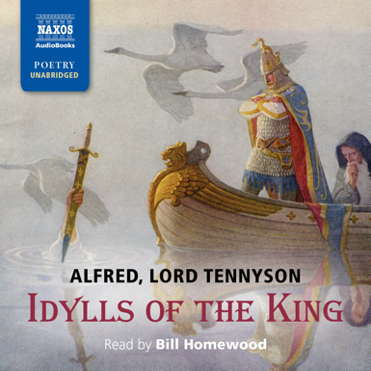
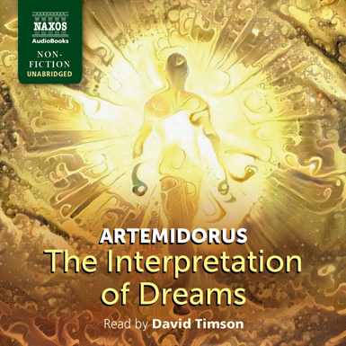

 | Cat No. | ISBN | Title | Hrs | Prices | Author | Reader
Jul | NA0544 | 978-1-78198-408-6 | NEWS FROM NOWHERE | 9.25 | £19.50, $27.00, €22.00 | William Morris | Andrew Wincott
 | NA0545 | 978-1-78198-409-3 | BASIL | 11.5 | £23.00, $31.00, €26.00 | Wilkie Collins | Nicholas Boulton
 | NA0546 | 978-1-78198-410-9 | THE CHARTERHOUSE OF PARMA | 19.25 | £36.00, $49.00, €40.50 | Stendhal | Nicholas Boulton
 | NA0547 | 978-1-78198-411-6 | THE SONG OF ROLAND | 4.5 | £11.00, $15.00, €12.50 |  | Bill Homewood
 | NA0541 | 978-1-78198-405-5 | THE INTERPRETATION OF DREAMS | 10.75 | £21.50, $29.00, €24.00 | Artemidorus | David Timson
Aug | NA0555 | 978-1-78198-419-2 | UNCLE SILAS | 17.25 | £33.00, $44.00, €37.00 | Sheridan Le Fanu | Georgina Sutton
 | NA0549 | 978-1-78198-413-0 | RURAL RIDES | 22.25 | £39.00, $54.00, €44.00 | William Cobbett | Peter Wickham
 | NA0550 | 978-1-78198-414-7 | CHILDHOOD, BOYHOOD AND YOUTH | 14.5 | £27.00, $37.00, €31.00 | Leo Tolstoy | Roger May
Sep | NA0551 | 978-1-78198-415-4 | LETTERS | 14. 5 | £27.00, $37.00, €31.00 | Pliny the Younger | Russell Bentley with Ben Onwukwe
 | NA0552 | 978-1-78198-416-1 | VERA | 7.75 | £18.00, $25.00, €20.50 | Elizabeth von Arnim | Lucy Scott
 | NA0553 | 978-1-78198-417-8 | THE NETHER WORLD | 16.5 | £33.00, $44.00, €37.00 | George Gissing | Nicholas Boulton
 | NA0561 | 978-1-78198-426-0 | THE WHITE GUARD | 12 | £23.00, $31.00, €26.00 | Mikhail Bulgakov | Nicholas Boulton
Oct | NA0556 | 978-1-78198-420-8 | IDYLLS OF THE KING | 9.5 | £19.50, $27.00, €22.00 | Alfred, Lord Tennyson | Bill Homewood
 | NA0557 | 978-1-78198-421-5 | LA TERRE | 21 | £36.00, $49.00, €40.50 | Émile Zola | Leighton Pugh
 | NA0548 | 978-1-78198-412-3 | FAIRY TALES | 15 | £27.00, $37.00, €31.00 | George MacDonald | Georgina Sutton and David Timson
Nov | NA0560 | 978-1-78198-424-6 | WIELAND | 10.25 | £21.50, $29.00, €24.00 | Charles Brockden Brown | Laurel Lefkow
 | NA0558 | 978-1-78198-422-2 | SARTOR RESARTUS | 10.5 | £21.50, $29.00, €24.00 | Thomas Carlyle | Leighton Pugh

