N E W R E L E A S E I N F O R M A T I O N
J A N U A R Y − J U N E 2 0 2 3

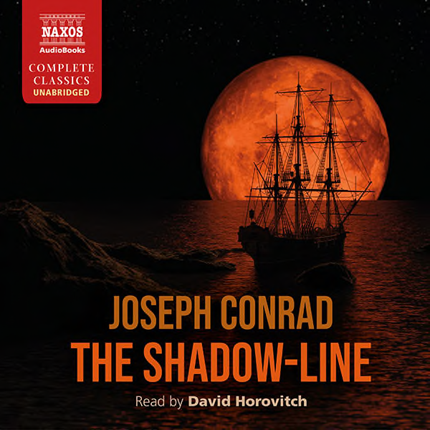
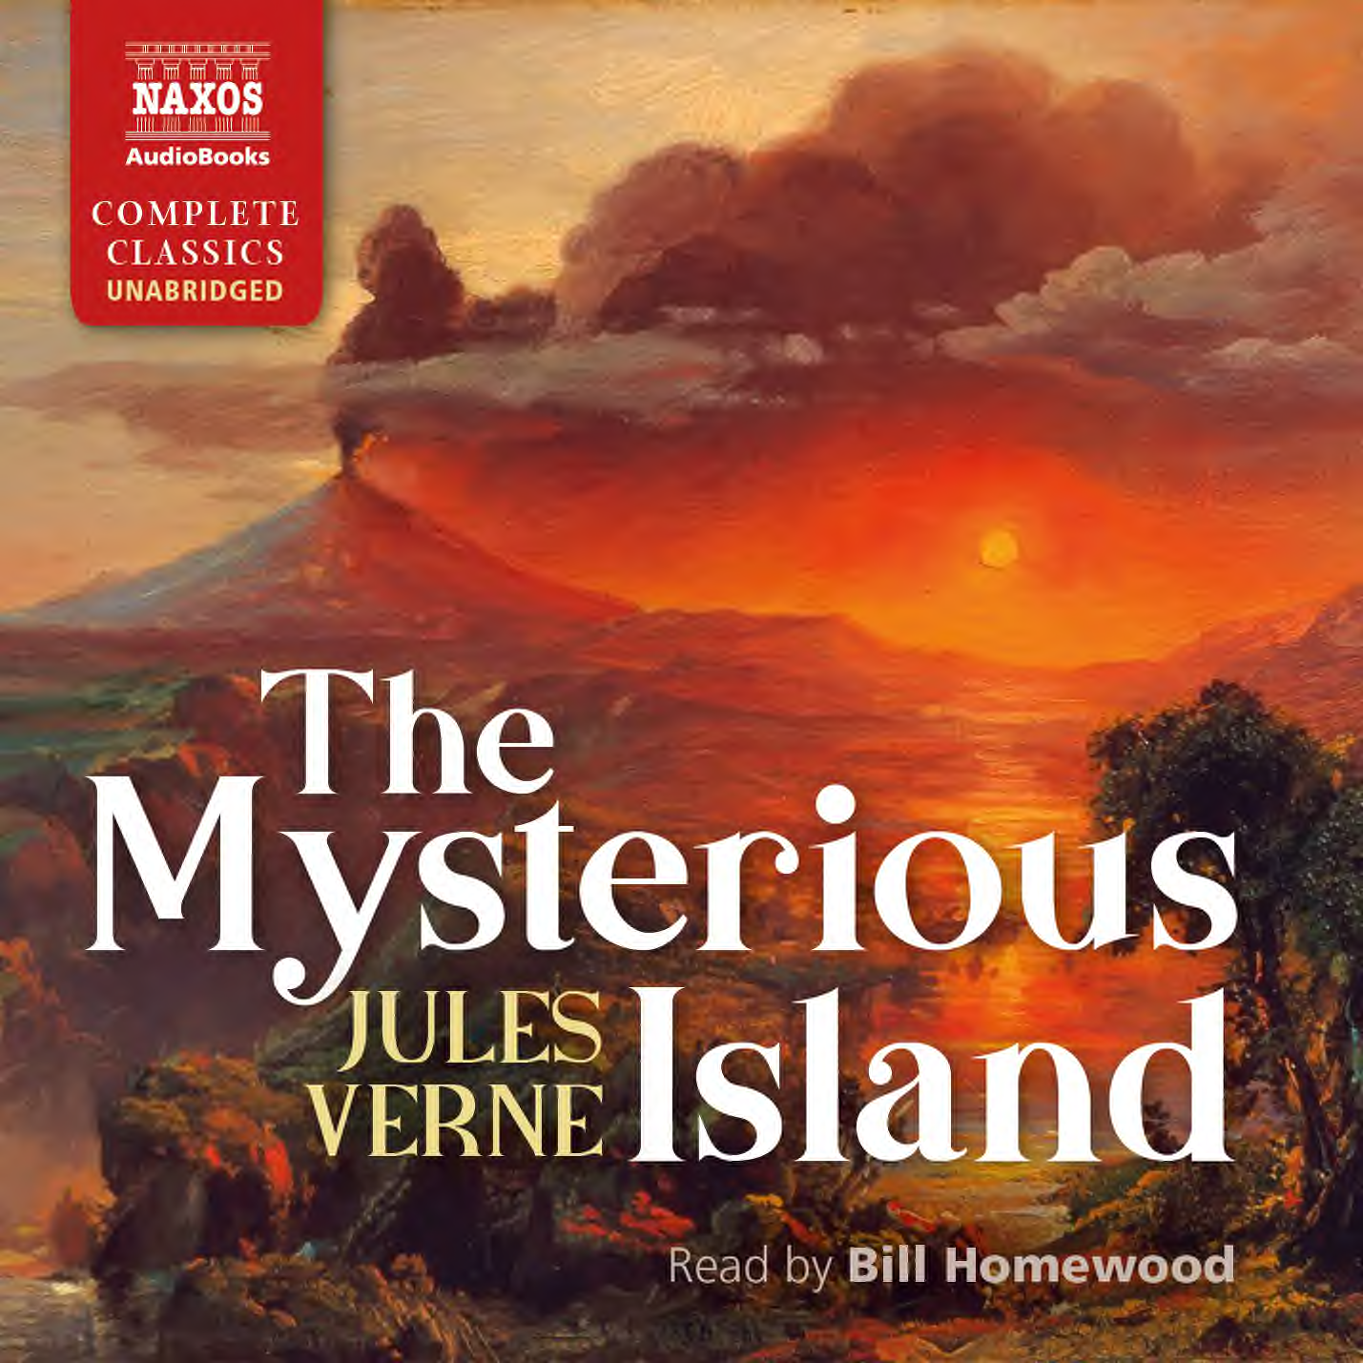
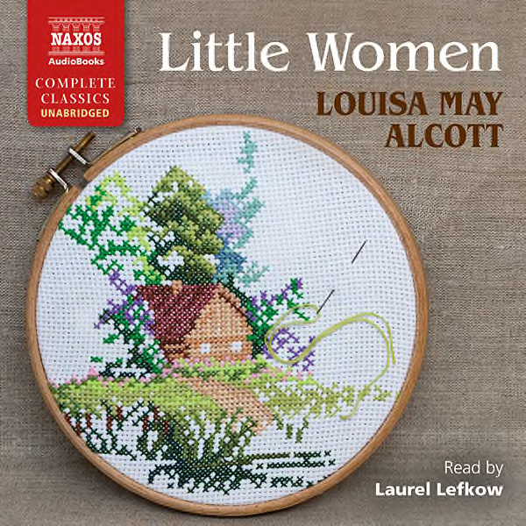

 | Cat No. | ISBN | Title | Hrs | Prices | Author | Reader
Jan | NA0562 | 978-1-78198-427-7 | PRAGMATISM AND THE MEANING OF TRUTH | 11.75 | £23.00, $31.00, €26.00 | William James | Adam Sims
 | NA0564 | 978-1-78198-429-1 | JEZEBEL’S DAUGHTER | 10.75 | £21.50, $29.00, €24.00 | Wilkie Collins | Nicholas Boulton
 | NA0565 | 978-1-78198-430-7 | THE FIRST MEN IN THE MOON | 7 | £16.00, $21.50, €18.50 | H.G. Wells | Jonathan Keeble
 | NA0580 | 978-1-78198-445-1 | LITTLE WOMEN | 21 | £36.00, $49.00, €40.50 | Louisa May Alcott | Laurel Lefkow
Feb | NA0566 | 978-1-78198-431-4 | THE SHADOW-LINE | 4.75 | £11.00, $15.00, €12.50 | Joseph Conrad | David Horovitch
 | NA0567 | 978-1-78198-432-1 | AGAINST NATURE | 7.75 | £18.00, $25.00, €20.50 | Joris-Karl Huysmans | Leighton Pugh
 | NA0568 | 978-1-78198-433-8 | THE ENCHANTED APRIL | 8.25 | £18.00, $25.00, €20.50 | Elizabeth von Arnim | Lucy Scott
 | NA0569 | 978-1-78198-434-5 | THE CONFESSIONS OF ARSÈNE LUPIN | 7.75 | £18.00, $25.00, €20.50 | Maurice Leblanc | David Timson
 | NA0581 | 978-1-78198-457-4 | JIGSAW | 15 | £27.00, $37.00, €31.00 | Sybille Bedford | Siân Thomas
Mar | NA0570 | 978-1-78198-435-2 | THE MYSTERIOUS ISLAND | 18 | £33.00, $44.00, €37.00 | Jules Verne | Bill Homewood
 | NA0572 | 978-1-78198-437-6 | THE CROCK OF GOLD | 5.75 | £13.00, $17.50, €14.50 | James Stephens | Gerry O’Brien
 | NA0563 | 978-1-78198-428-4 | THE HAND OF ETHELBERTA | 16 | £29.00, $39.00, €33.50 | Thomas Hardy | Fenella Woolgar
Apr | NA0573 | 978-1-78198-438-3 | THE RULE OF ST BENEDICT | 2.5 | £9.00, $12.00, €10.50 | St Benedict | Jonathan Booth
 | NA0574 | 978-1-78198-439-0 | BELINDA | 18.75 | £36.00, $49.00, €40.50 | Maria Edgeworth | Lucy Scott
 | NA0571 | 978-1-78198-436-9 | THE GALLIC WAR | 10 | £19.50, $27.00, €22.00 | Caesar | David Timson
May | NA0575 | 978-1-78198-440-6 | THIS SIDE OF PARADISE | 9.5 | £19.50, $27.00, €22.00 | F. Scott Fitzgerald | Adam Sims
 | NA0576 | 978-1-78198-441-3 | THE ANTIQUARY | 18.5 | £33.00, $44.00, €37.00 | Sir Walter Scott | David Rintoul
 | NA0577 | 978-1-78198-442-0 | THE ITALIAN | 19 | £36.00, $49.00, €40.50 | Ann Radcliffe | Georgina Sutton
Jun | NA0578 | 978-1-78198-443-7 | THE HISTORY OF RASSELAS | 4.75 | £11.00, $15.00, €12.50 | Samuel Johnson | Peter Wickham
 | NA0579 | 978-1-78198-444-4 | IMPERIALISM | 5.25 | £13.00, $17.50, €14.50 | Lenin | Peter Wickham
 | NA0554 | 978-1-78198-418-5 | LADY MACBETH OF THE MTSENSK DISTRICT AND OTHER SHORT STORIES | 10 | £21.50, $29.00, €24.00 | Nikolai Leskov | Nicholas Boulton

