N E W R E L E A S E I N F O R M A T I O N
J U L Y − D E C E M B E R 2 0 2 3

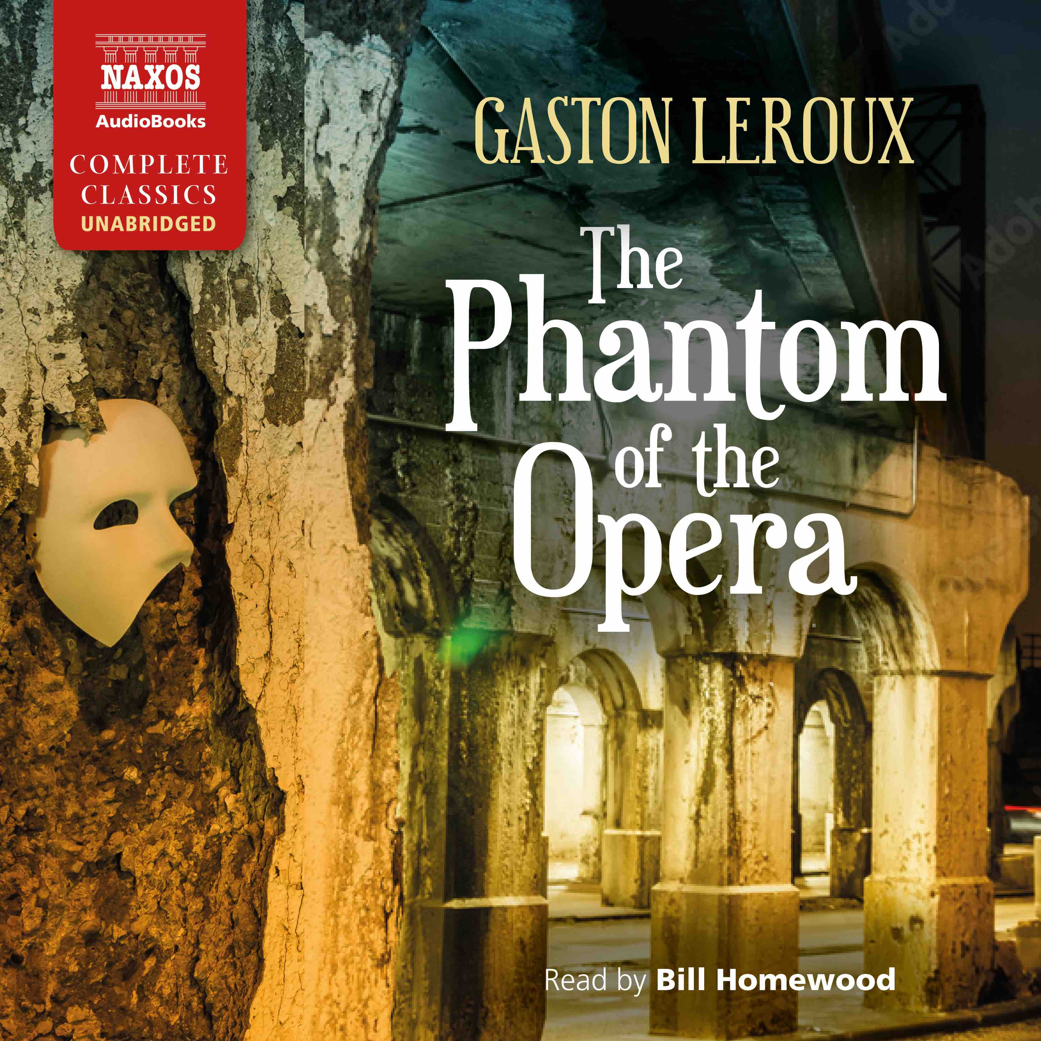

 | Cat No. | ISBN | Title | Hrs | Prices | Author | Reader
Jul | NA0587 | 978-1-78198-470-3 | ELIZABETH AND HER GERMAN GARDEN | 3.75 | £11.00, $15.00, €12.50 | Elizabeth von Arnim | Lucy Scott
 | NA0583 | 978-1-78198-466-6 | THE DEVIL’S DICTIONARY | 8.75 | £19.50, $27.00, €22.00 | Ambrose Bierce | Robert G Slade
 | NA0584 | 978-1-78198-467-3 | A LADY’S LIFE IN THE ROCKY MOUNTAINS | 7.75 | £18.00, $25.00, €20.50 | Isabella Bird | Clare Wille
Aug | NA0585 | 978-1-78198-468-0 | THE PHANTOM OF THE OPERA | 10.5 | £21.50, $29.00, €24.00 | Gaston Leroux | Bill Homewood
 | NA0586 | 978-1-78198-469-7 | THE LAW AND THE LADY | 14.75 | £27.00, $37.00, €31.00 | Wilkie Collins | Lucy Scott
Sep | NA0594 | 978-1-78198-477-2 | THE ADVENTURES OF BARON MUNCHAUSEN | 5.25 | £13.00, $17.50, €14.50 | Rudolf Erich Raspe | Peter Wickham
 | NA0588 | 978-1-78198-471-0 | THE WAY OF ALL FLESH | 17.5 | £33.00, $44.00, €37.00 | Samuel Butler | David Timson
 | NA0589 | 978-1-78198-472-7 | HESTER | 22.5 | £39.00, $54.00, €44.00 | Margaret Oliphant | Georgina Sutton
Oct | NA0590 | 978-1-78198-473-4 | THE SECRET HISTORY | 4.25 | £11.00, $15.00, €12.50 | Procopius | David Timson
 | NA0591 | 978-1-78198-474-1 | DANGEROUS LIAISONS | 17 | £33.00, $44.00, €37.00 | Choderlos de Laclos | Nicholas Boulton, Georgina Sutton and cast
 | NA0592 | 978-1-78198-475-8 | THE QUEST FOR CORVO: AN EXPERIMENT IN BIOGRAPHY | 10.5 | £21.50, $29.00, €24.00 | A.J.A. Symons | Rupert Degas
Nov | NA0593 | 978-1-78198-476-5 | ELMER GANTRY | 17 | £33.00, $44.00, €37.00 | Sinclair Lewis | Adam Sims
 | NA0582 | 978-1-78198-465-9 | LES GRANDES MEAULNES | 7 | £16.00, $21.50, €18.50 | Alain-Fournier | Leighton Pugh
 | NA0596 | 978-1-78198-484-0 | THE MAN WHO DISAPPEARED (AMERICA) | 10.5 | £21.50, $29.00, €24.00 | Franz Kafka | Leighton Pugh
 | NA0595 | 978-1-78198-483-3 | AT THE EDGE OF THE NIGHT | 4 | £11.00, $15.00, €12.50 | Friedo Lampe | Jot Davies

