N E W R E L E A S E I N F O R M A T I O N
J A N U A R Y − J U L Y 2 0 2 4

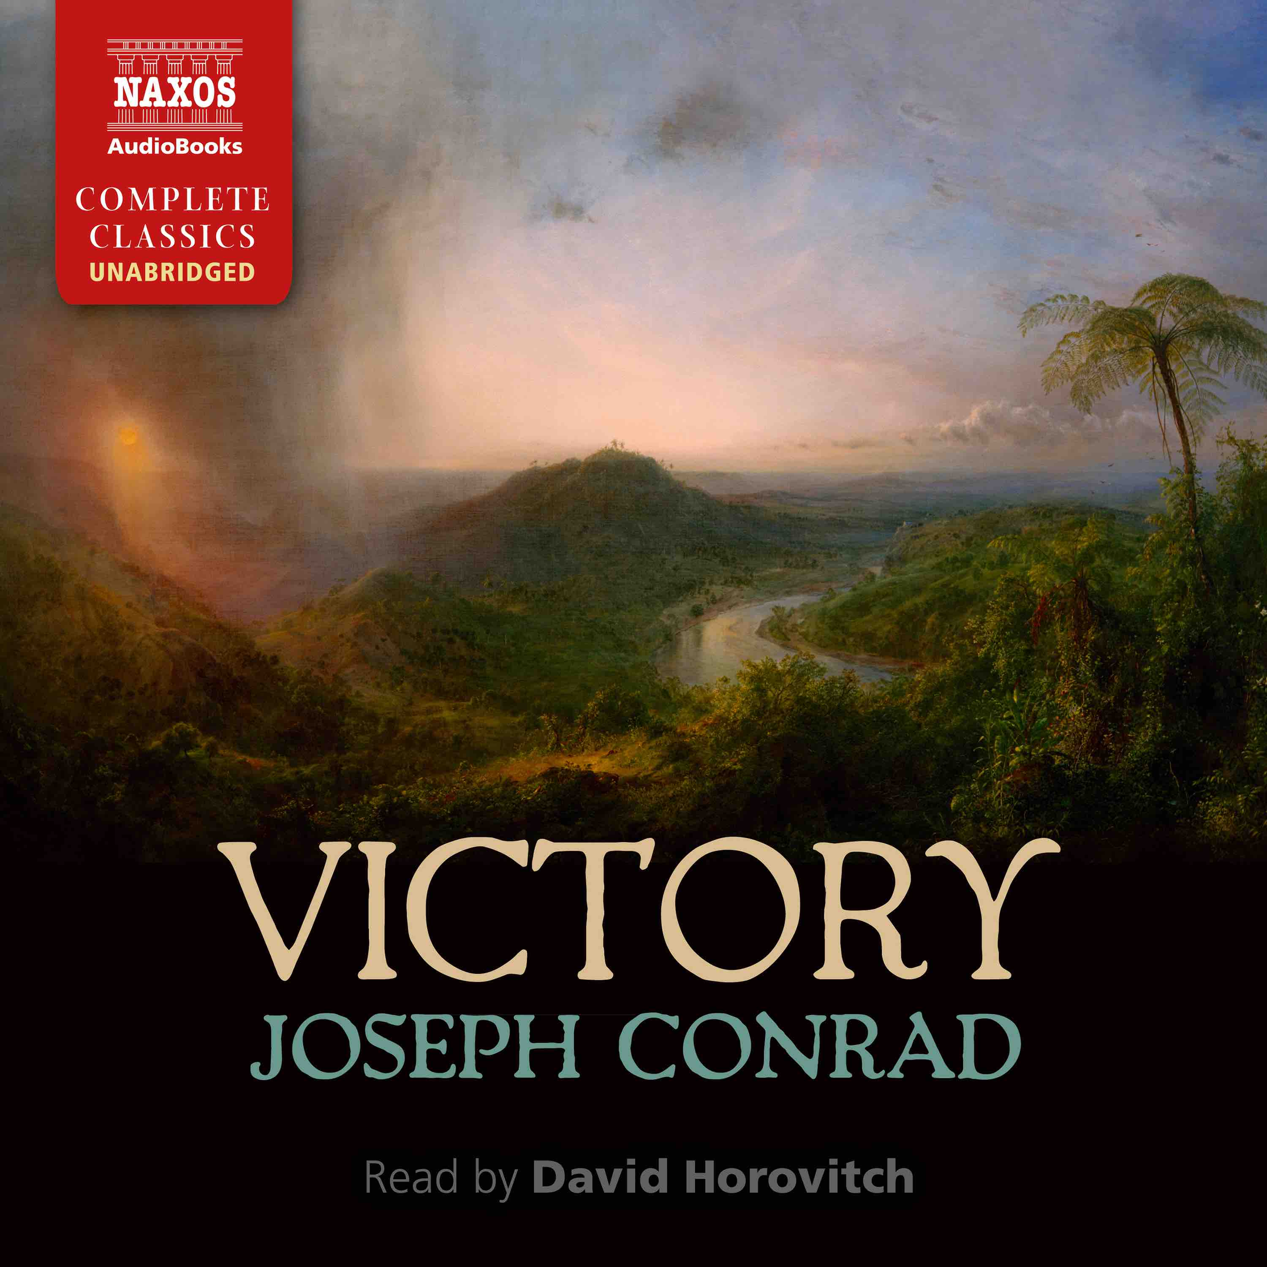
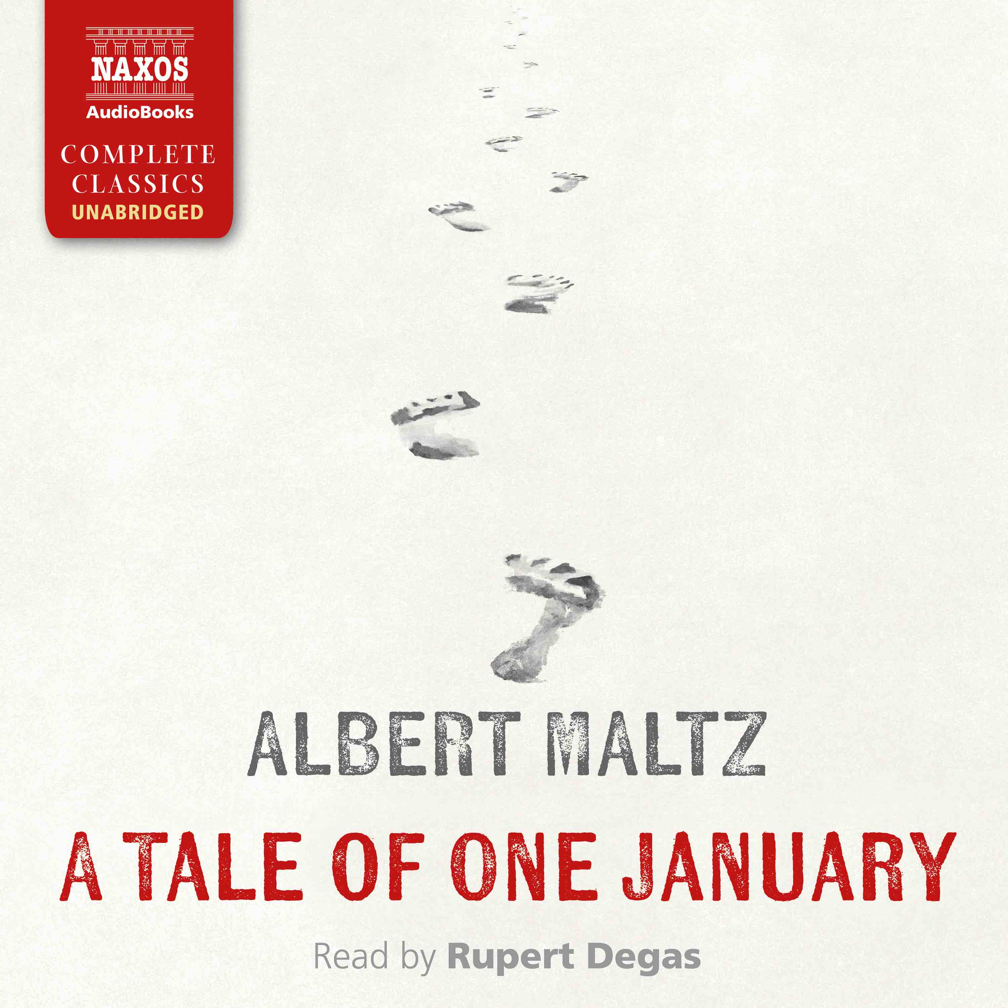
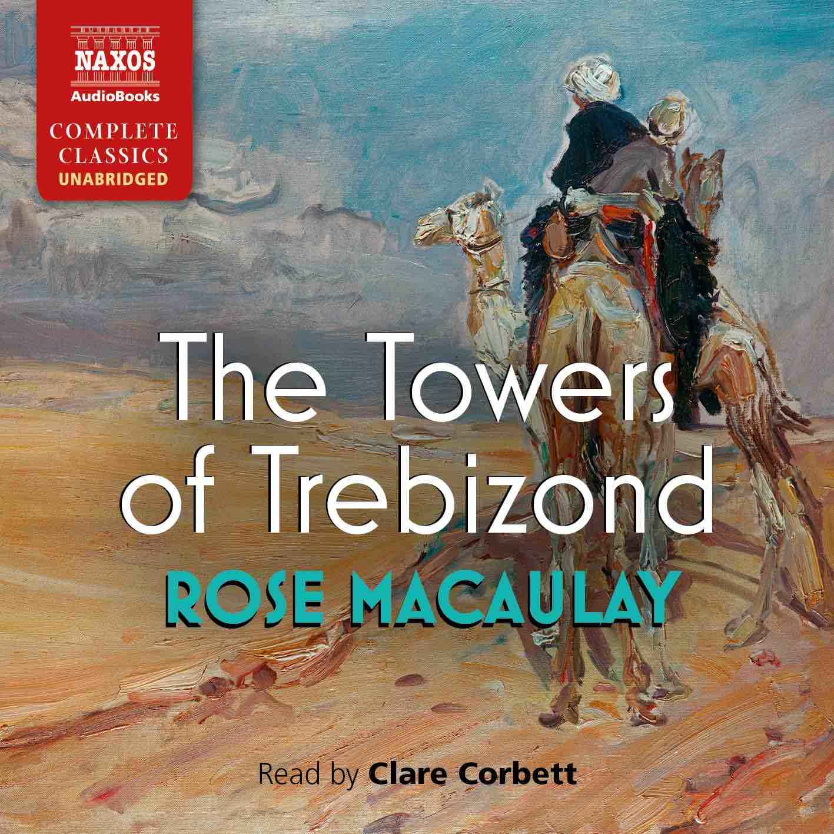
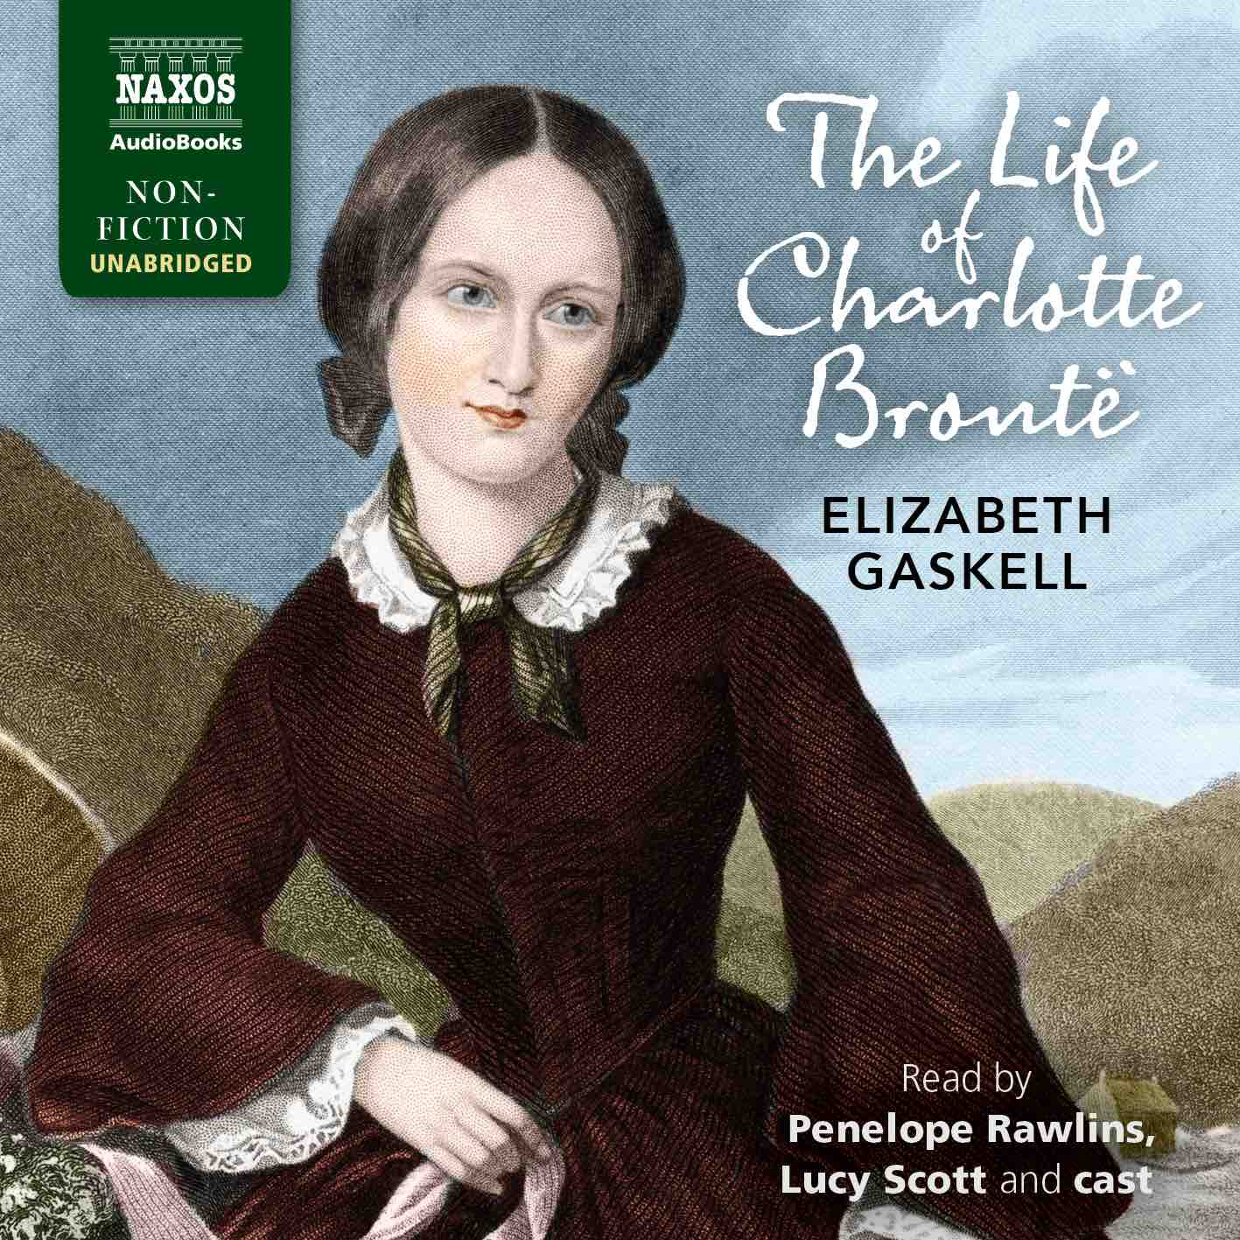

 | Cat No. | ISBN | Title | Hrs | Prices | Author | Reader
Jan | NA0598 | 978-1-78198-486-4 | SCENES OF CLERICAL LIFE | 15 | £29.00, $39.00, €33.50 | George Eliot | Clare Wille
 | NA0599 | 978-1-78198-487-1 | THE HOLLOW NEEDLE: THE FURTHER ADVENTURES OF ARSÈNE LUPIN | 7.75 | £18.00, $25.00, €20.50 | Maurice Leblanc | David Timson
 | NA0600 | 978-1-78198-488-8 | VICTORY | 14.5 | £27.00, $37.00, €31.00 | Joseph Conrad | David Horovitch
 | NA0616 | 978-1-78198-505-2 | A TALE OF ONE JANUARY | 5.75 | £13.00, $17.50, €14.50 | Albert Maltz | Rupert Degas
Feb | NA0601 | 978-1-78198-489-5 | THE WELL OF LONELINESS | 18.5 | £33.00, $44.00, €37.00 | Radclyffe Hall | Lucy Scott
 | NA0602 | 978-1-78198-490-1 | THE NATURAL HISTORY OF SELBORNE | 10.25 | £21.50, $29.00, €24.00 | Gilbert White | Peter Wickham
 | NA0614 | 978-1-78198-502-1 | A CHILD OF THE JAGO | 7 | £16.00, $21.50, €18.50 | Arthur Morrison | Nicholas Boulton
 | NA0621 | 978-1-78198-511-3 | THE TOWERS OF TREBIZOND | 10 | £21.50, $29.00, €24.00 | Rose Macaulay | Clare Corbett
 | NA0597 | 978-1-78198-485-7 | ORLANDO | 9.25 | £19.50, $27.00, €22.00 | Virginia Woolf | Juliet Stevenson
Mar | NA0604 | 978-1-78198-492-5 | TWENTY YEARS AFTER | 27.5 | £46.00, $63.00, €52.00 | Alexandre Dumas | Bill Homewood
 | NA0611 | 978-1-78198-499-4 | MONEY | 18 | £33.00, $44.00, €37.00 | Émile Zola | Leighton Pugh
 | NA0606 | 978-1-78198-494-9 | THE LOVE POEMS | 6 | £13.00, $17.50, €14.50 | Ovid | David Timson
 | NA0620 | 978-1-78198-510-6 | THE WORLD MY WILDERNESS | 6.5 | £16.00, $21.50, €18.50 | Rose Macaulay | Clare Corbett
 | NA0622 | 978-1-78198-512-0 | A LONG DAY IN A SHORT LIFE | 15.5 | £29.00, $39.00, €33.50 | Albert Maltz | Rupert Degas
Apr | NA0607 | 978-1-78198-495-6 | THE FABLE OF THE BEES | 25 | £42.00, $58.00, €48.00 | Bernard Mandeville | David Timson, Stephanie Racine, Will Kirk, Justin Avoth
 | NA0608 | 978-1-78198-496-3 | FRÄULEIN SCHMIDT AND MR ANSTRUTHER | 10 | £21.50, $29.00, €24.00 | Elizabeth von Arnim | Lucy Scott
 | NA0609 | 978-1-78198-497-0 | THE LAIR OF THE WHITE WORM | 6.25 | £16.00, $21.50, €18.50 | Bram Stoker | Matt Addis
 | NA0619 | 978-1-78198-509-0 | WHAT NOT | 5.75 | £13.00, $17.50, €14.50 | Rose Macaulay | Clare Corbett
May | NA0610 | 978-1-78198-498-7 | SUMMER | 7.75 | £18.00, $25.00, €20.50 | Edith Wharton | Laurel Lefkow
 | NA0605 | 978-1-78198-493-2 | POOR MISS FINCH | 18 | £33.00, $44.00, €37.00 | Wilkie Collins | Lucy Scott, Penny Rawlins, Nigel Pilkington, Georgina Sutton
 | NA0612 | 978-1-78198-500-7 | DEVOTIONS AND DEATH’S DUEL | 6.5 | £16.00, $21.50, €18.50 | John Donne | Jonathan Booth
 | NA0618 | 978-1-78198-508-3 | POTTERISM | 8 | £18.00, $25.00, €20.50 | Rose Macaulay | Clare Corbett
Jun | NA0613 | 978-1-78198-501-4 | THE LIFE OF CHARLOTTE BRONTË | 23 | £39.00, $54.00, €44.00 | Elizabeth Gaskell | Lucy Scott, Penelope Rawlins, Georgina Sutton, Sarah Lambie, David Timson and Nigel Pilkington
 | NA0603 | 978-1-78198-491-8 | IN THE WORLD | 14 | £27.00, $37.00, €31.00 | Maxim Gorky | Nicholas Boulton
 | NA0615 | 978-1-78198-503-8 | STUDIES IN THE HISTORY OF THE RENAISSANCE | 6 | £13.00, $17.50, €14.50 | Walter Pater | Leighton Pugh
 | NA0617 | 978-1-78198-507-6 | CREWE TRAIN | 9 | £19.50, $27.00, €22.00 | Rose Macaulay | Clare Corbett

